PHEK GOVERNMENT COLLEGE
DEAPRTMENT OF PHYSICS
B.Sc 6TH SEMESTER (HONOURS)
FIELD WORK, 2022
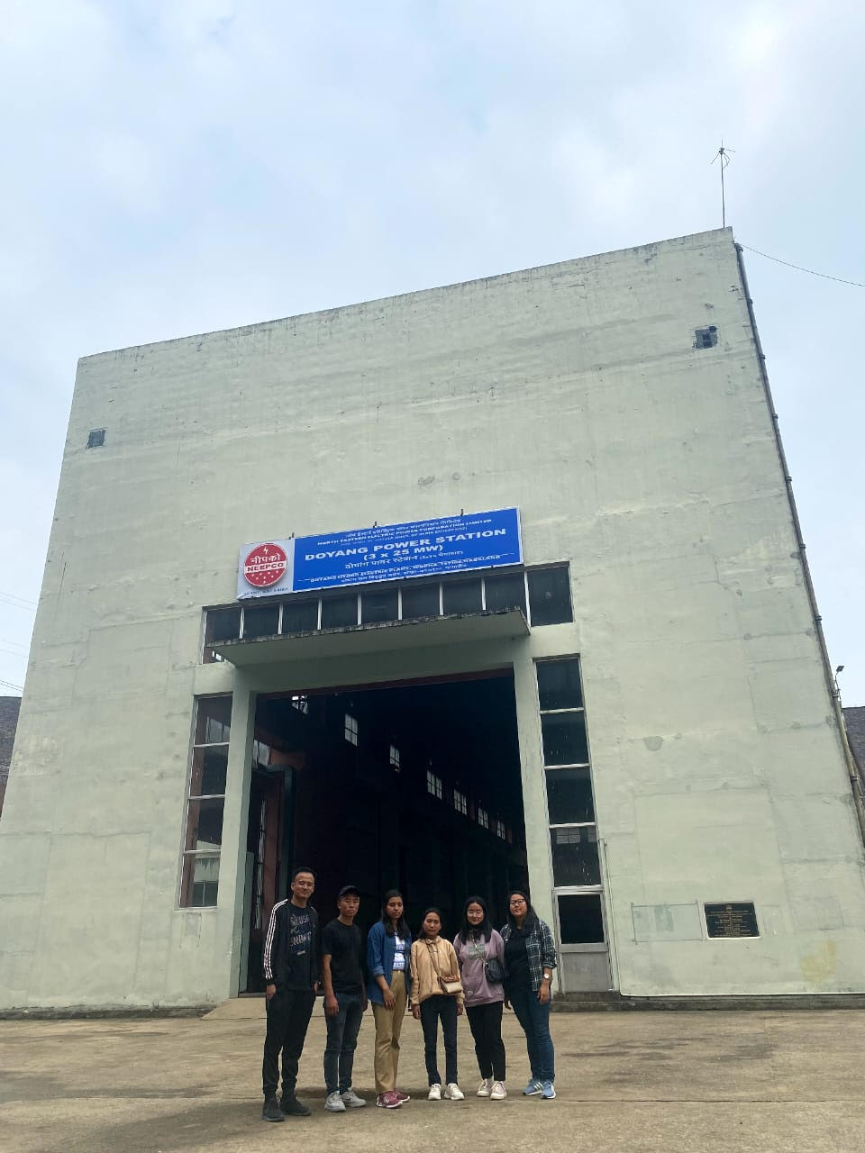
Fig: B.Sc Physics 6th Semester students field work at Doyang Power Station
ASSISTANT PROFESSORS:
1. Lidemo B Kithan
2. Vinituono Krose

STUDENTS
- Michehu Rhakho
- Reena Thapa
- Mutulu Veyie
- Venekholu Chizo

