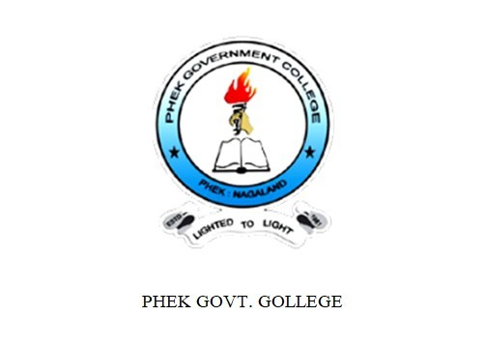
GENDER AUDIT REPORT 2023

CONTENTS
- Preface
- College Profile
- Data Analysis
- Gender sensitization Initiatives
- Conclusion

PREFACE

Gender equality is the pursuit of equal treatment for all with equal rights and opportunities. It advocates for the elimination of discrimination based on gender and the promotion of equal representation and participation in all aspects. Besides being a fundamental human right, it is essential to achieve full human potential and empower human.
The Gender Audit of our college was conducted to find out whether the different aspects and areas in the campus have a gender balanced representation.

COLLEGE PROFILE
Phek Government College is located on a hill side with a campus area of 38 acres on the outskirts of Phek Town. It was granted permanent affiliation to Nagaland University in 2023.The college offers Bachelor of Arts in Education, Economics, History, Political Science and English with both major and minor courses. For Bachelor of Science programmes, the college offers major courses in Botany and Zoology and minor courses in Chemistry, Mathematics and Physics. It also hosts an IGNOU study center offering Post Graduate, Diploma and Certificate courses. The college has total faculty strength of forty one and one librarian. Nine faculty members have doctoral degree while ten are pursuing the same. There are twenty eight ministerial and supporting staffs.

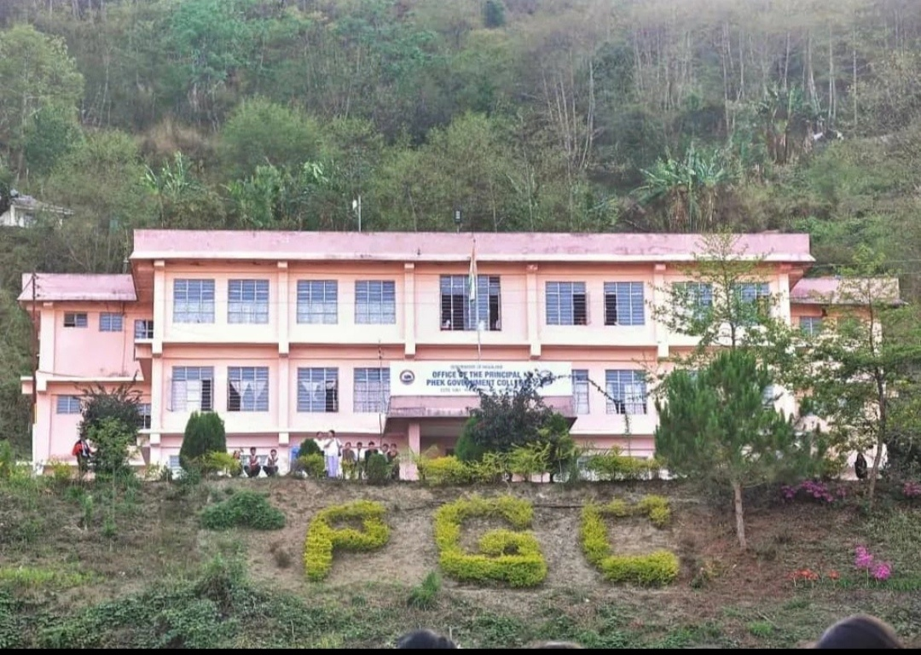

DATA ANALYSIS
Sl.no | Year | Total no. of Students | Total no. of Boys | Total no. of Girls | % of Boys | % of Girls
1. | 2023- 2024 | 268 | 130 | 138 | 49% | 51%
Table I: Gender wise details of total students in the college

Graph I

Table I shows the gender wise detail of the college for the year 2023-2024. Out of the total number of students, 130 students are boys and 138 students are girls. Graph I represent the percentage of Girls to boys, i.e.51% girls and 49% boys.
Table II: Gender wise details for Bachelor of Arts
Sl.no | Year/  Semester | Total No. of Students | Total no. of Boys | Total no. of Girls | % of Boys | % of  Girls
1 | 2023-2024 | 251 | 123 | 128 | 49% | 51%
2 | II | 85 | 37 | 48 | 44% | 56%
3 | IV | 78 | 45 | 33 | 58% | 42%
4 | VI | 88 | 41 | 47 | 47% | 53%

Graph II: Semester wise gender details of Bachelor of Arts

Table II indicates the gender wise details for Bachelor of Arts for the year 2023-2024 in total and semester wise. Out of 251 total students in Arts stream, 123 i.e 49% are boys and 128 i.e 51% are girls. In Semester-II, the total number of students is 85 out of which 37 i.e 44% are boys and 48 i.e 56% are girls. In IV Semester, the total number of students is 78 out of which 45 i.e 58% are boys and 33 i.e 42% are girls. In VI Semester, the total number of students is 88 out of which 41 i.e 47% are boys and 47 i.e 53% are girls.
Table III: Gender wise detail for Bachelor of Science
Sl.no | Year/  Semester | Total No. of Students | Total no. of Boys | Total no. of Girls | % of Boys | % of Girls
1 | 2023-2024 | 17 | 7 | 10 | 41% | 59%
2 | II | 2 | 1 | 1 | 50% | 50%
3 | IV | 4 | 2 | 2 | 50% | 50%
4 | VI | 12 | 4 | 8 | 33% | 67%

Table III indicates the gender wise details for Bachelor of Science for the year 2023-2024 in total and semester wise. Out of 17 total students in Science stream, 7 i.e. 41% are boys and 10 i.e. 59% are girls. In Semester-II, the total number of students is 2 out of which 1 i.e. 50% are boys and 1 i.e 50% are girls. In IV Semester, the total number of students is 4 out of which 2 i.e 50% are boys and 2 i.e 50% are girls. In VI Semester, the total number of students is 12 out of which 4 i.e 33% are boys and 8 i.e 67% are girls.
Graph iii gives a better picture of boys and girls in semester II , IV and VI in science stream.

Graph III: Semester wise gender details of Bachelor of Science

ANALYSIS
From the analysis, it is clear that there is fairly an equitable variation in the gender distribution across the two streams (Arts and Science). It is clear that both the streams have higher percentage of girls over boys but there is not much difference(Girls comprising of 51% in Arts and 59% in Science).This highlights that on the basis of gender, there is not much varying preferences and interests of students when selecting their academic paths.
Overall, there are differences in the total number of students in both the streams. The Arts stream has higher enrolment indicating its popularity and relevance in the academic landscape. On the other hand, Science stream has relatively lower students enrolment suggesting either specific interest or lesser applicants for the programme.

GENDER SENSITISATION INITIATIVES
Phek Government College is a co-ed institution. Some notable initiatives undertaken on the lines of gender sensitization are as follows:
- Women Development Cell: It focuses on the importance of women related issues and over the past five years has carried out some of the activities for the promotion of gender equity and sensitization:
- On 20th September, 2018 the Women Development Cell Organized talks on “Social Etiquette of Women” and “Importance of Women Education” in the college.
- A free medical camp was conducted on 28th September, 2018 in collaboration with the District Hospital Phek, organized by Women Development Cell.
- On 24th July, 2019, the Girls Music Band – “The Dimension” participated in the district level Girls Music Band Competition organized by Phek District Administration along with District Level Centre for Women Mahila Shakti Kendra,Phek, under Beti Bachao Beti Padhao.
- On 15th October, 2021 an awareness program on “Right to Education Act” was organized by Phek Government College in collaboration with District Legal Service Authority.
- Provision of sanitary napkins for emergency cases as part of hygiene or dignity kits are maintained under the care of Women Development Cell.
- On 8th March, 2022, International Women’s Day was celebrated on the theme “Break the Bias” organized by the Women Development Cell.
- CCTVs are installed at strategic points to ensure safety and security for all, leaving no room for any unnoticed activity. Any act of violence, misconduct and misdemeanor within the college premises are promptly dealt with and penalized. The Disciplinary, Anti-Ragging and Anti-Harassment Cell also keep a check on any indisciplinary act within the campus.

- Separate common rooms for boys and girls are provided to ensure private space relaxation and recreation. Books, magazines, ludo, chess, table tennis etc are available for leisure time.
- The college has hostel facilities for both boys and girls. Separate washroom provisions are made available in the college premises.
- The Career Guidance and Counseling Cell assists students in choosing suitable career options and supports them in their mental and emotional well being. Guidance is provided based on assessments of skills, interests, and values. They help individuals explore various career options, set goals, and develop plans for educational and professional growth. The aim is to empower individuals in making informed decisions about their careers.
- Opportunities are given to both boys and girls in NCC and NSS recruitment. Provision for women representative in the Students’ Union as Women Coordinator is reserved.
- A counseling room is dedicated for all where one can seek assistance for any issues. Students experiencing personal problems or other issues can seek help to cope with their problems. Besides this, mentoring sessions are held for all at regular intervals.

CONCLUSION
The college’s gender sensitization initiative has received significant support which indicates their effectiveness. The presence of Disciplinary, Anti-Ragging and Anti-Harassment Cell has a positive impact on the institution. During the studied period, no case of harassment in any form was reported.
The study helped the college identify its strengths in promoting gender sensitivity and equal opportunities. It also highlights areas that require improvements, allowing the college to address any concerns and make necessary changes to create a more inclusive and supportive environment for the students. All in all, the study does show that there is a balanced representation of gender in the institution.

Photo Gallery
Ladies posed with cross arms on International Women’s’ Day ( 8th March 2022) with the theme “Break the Bias”

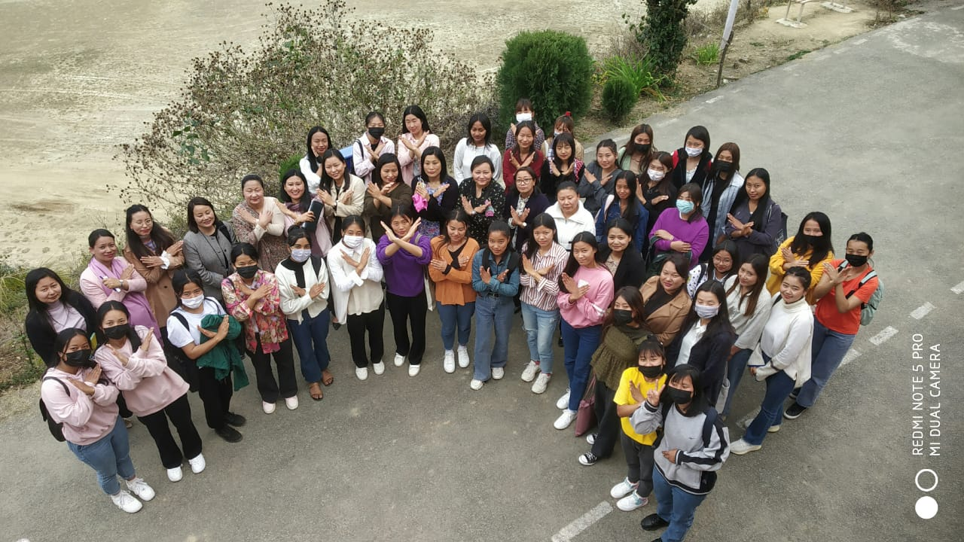 20th September,2018-Talk on “Social Etiquette of Women” & “Importance of Women Education”
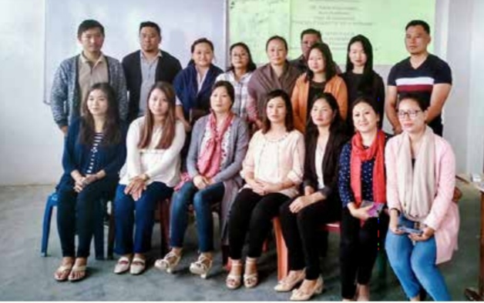
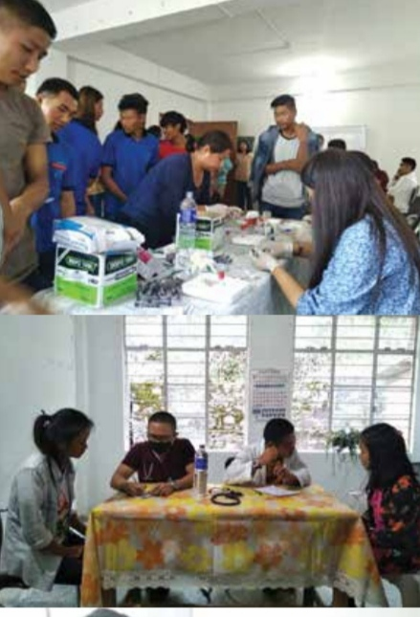Free Medical Camp with District Hospital on 28th September,2018
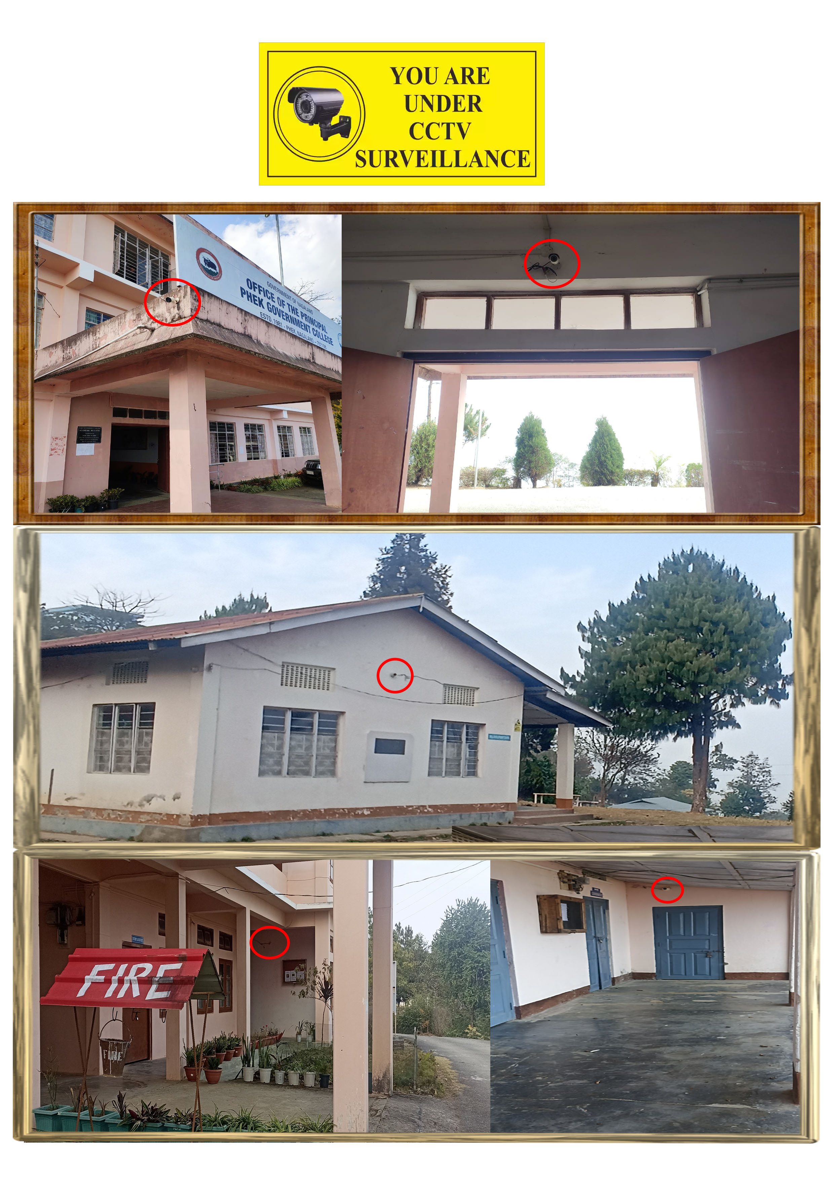CCTVs at strategic locations in the campus to ensure safety and security

Separate common room facilities for students to relax and enjoy at their leisure time
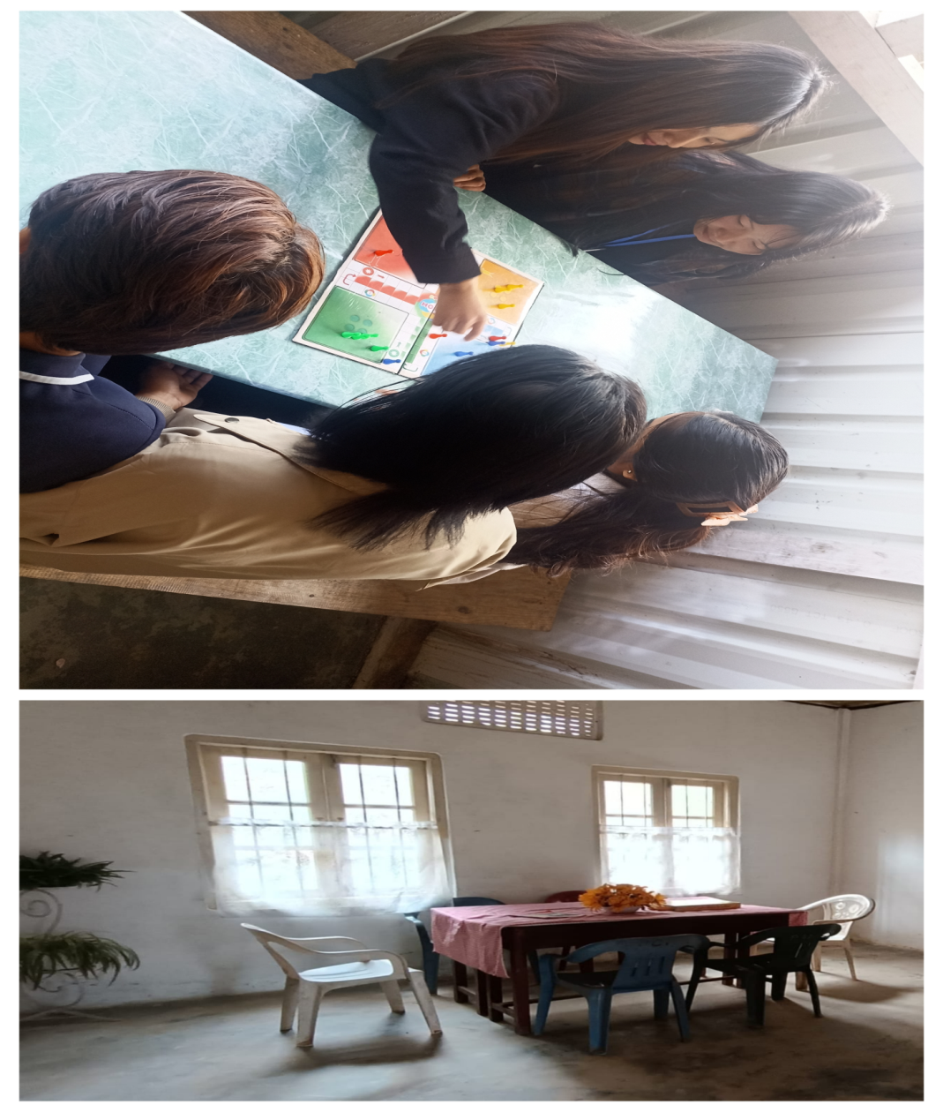
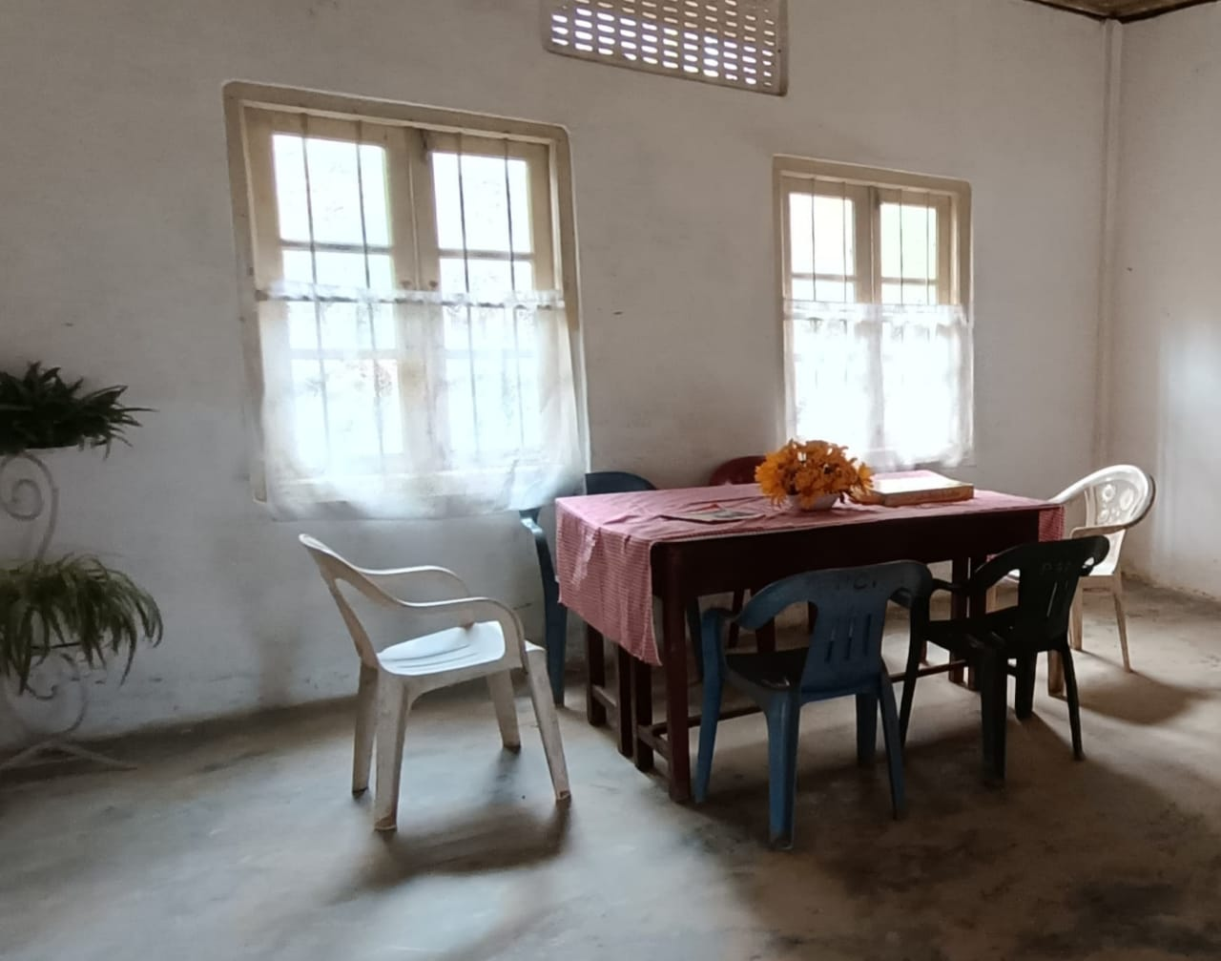


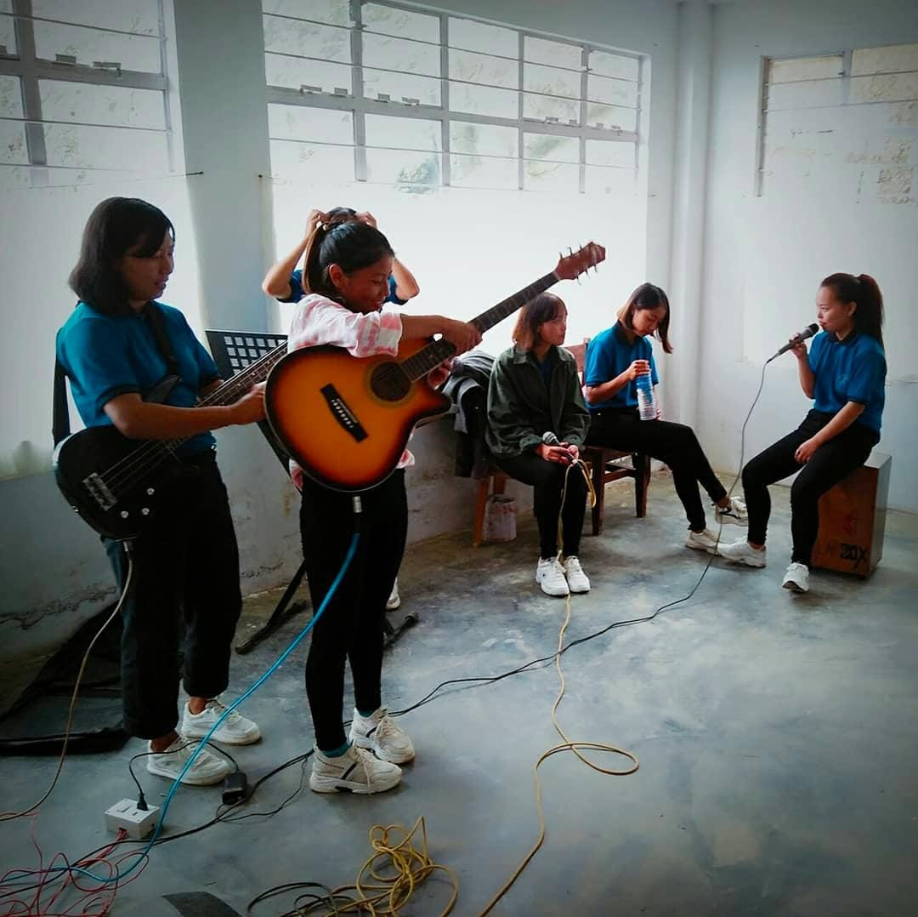
“THE DIMENSION BAND” – the all girls music band practicing for the Girls Music Band Competition

GENDER AUDIT TEAM

(Dr.Thejotalu Nienu) (Ms. Khrutalu Domeh)
Assistant Professor Assistant Professor
Department of Economics Department of English

(Ms. Dziesetuonuo Linyu)
Assistant Professor
Department of Political Science

