PHEK GOVERNMENT COLLEGE
PHEK, NAGALAND


GREEN AUDIT REPORT 2023

CONTENTS
Green Audit Team | 3
Sketch map of the college | 4
Certificate | 5
Recommendation letter | 6-7
- Introduction  - Need of Green Audit  - Objectives of Green Audit | 8
- About College | 9
District Green Champion Certificate | 14
- Green Practices  - College Best Practice  - Best Practice of Botany Department | 15-17
- Activities conducted for green campus | 19-20
- List of Campus Flora | 26-37
- Waste Management | 38
- Water Management | 39
- Conclusion | 40

GREEN AUDIT TEAM
- Mr. Mughato K. Kiba, Assistant Professor, Department of Botany
- Mrs. Mhashevolu Medeo, Assistant Professor, Department of Education
- Mrs. Kupeu Mero, Assistant Professor, Department of Education

SKETCH MAP OF PHEK GOVERNMENT COLLEGE, PHEK
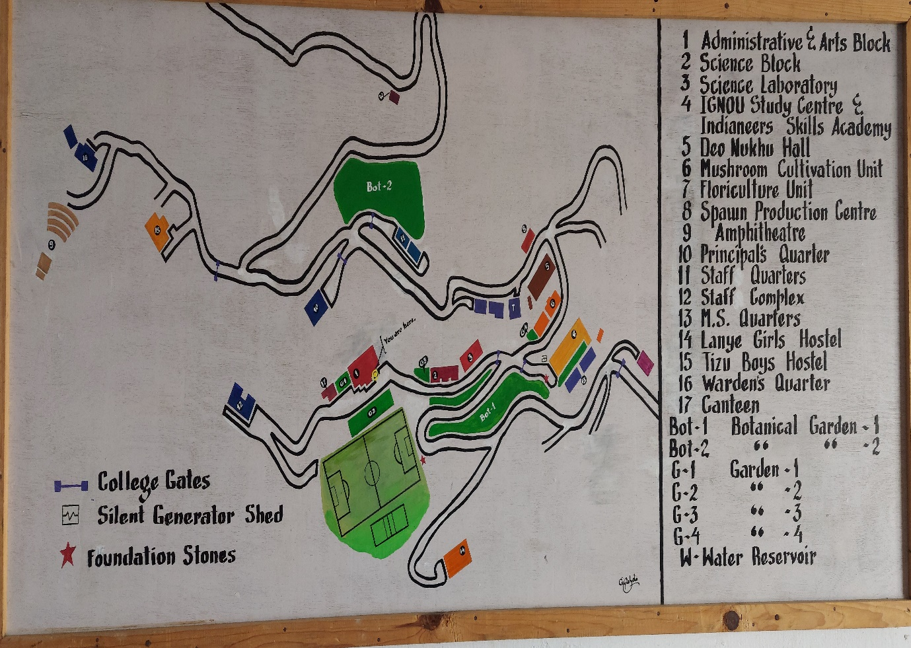

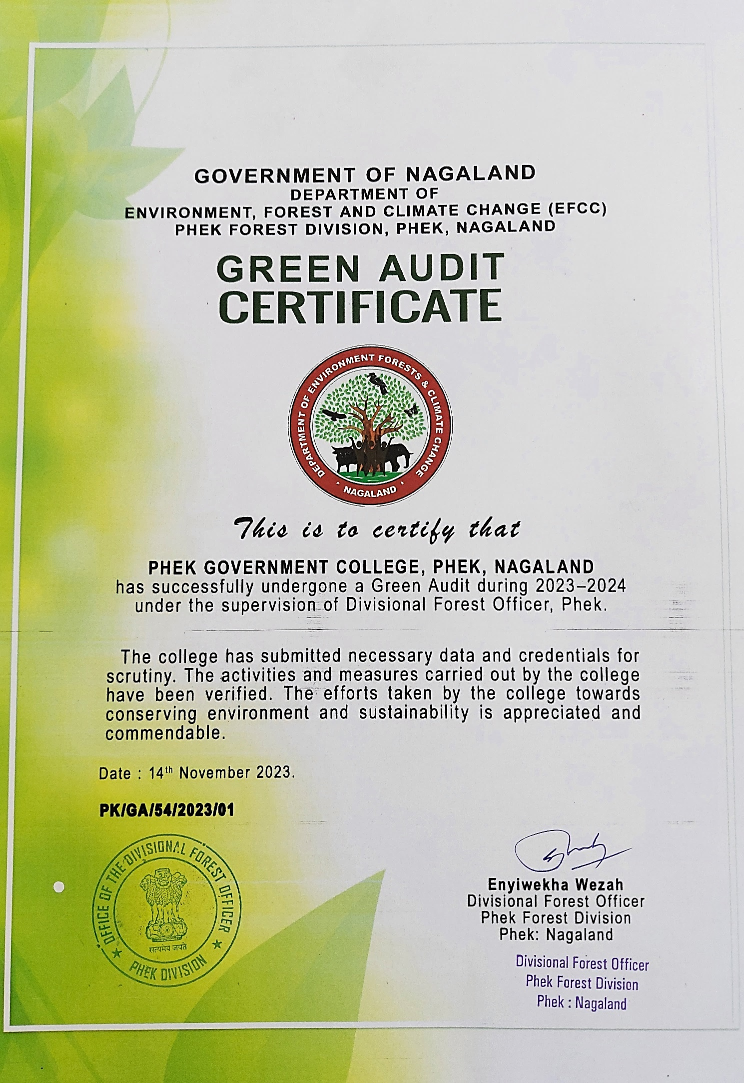




- INTRODUCTION:
Green audit as a self-analysis tool aims to assess the practices of the institution towards environment conservation, preservation, and sustainability. This self-assessment helps the institution identify the resources being utilized, the type and quantity of wastes generated, and take into considerations ways and means to bring changes in management of resources and environment. This way, it can create environmental values and consciousness among staff, teachers, and students.

  - NEED FOR GREEN AUDIT:
Today, environmental sustainability is gaining more prevalence both at the national and global level and therefore higher educational institutions can play a vital role in implementing environmental sustainability in its management system, promotion of a green campus, reduction of its carbon footprints. It is important for the college to evaluate its practices towards a green campus. A green audit will create consciousness of social responsibility among staff and students and enable us to understand the impact of our actions on our environment. A green audit will help all stakeholders to make careful plans, develop strategies and measures to manage our resources prudently.

  - OBJECTIVES OF GREEN AUDIT:
- To assess the institution’s current practices that may affect the environment such as, waste management, utilization of resources etc.
- To identify environmental issues in the campus and take corrective measures.
- To comply with Environmental laws and regulations.
- To strengthen the existing institution’s best practices of teachers-students synergy for green campus.
- To create awareness among students, staff, and teachers on environmental sustainability.
- To instill knowledge of conservation, preservation, protection, and promotion of flora within the campus and surrounding.

- ABOUT THE COLLEGE:
Phek Government College was established on 28th July 1981. The college is a center of higher learning for students in the remote region bordering Myanmar. Despite its remoteness, the college is NAAC accredited with B Grade in 2019 in its first cycle of assessment. The college is included in Section 2f and section 12B of the UGC Act of 1956.The college offers Bachelors Programme in Arts and Science. Presently, there are 270 students enrolled in both streams, the faculty strength stands at 41 and the number of staff stands at 29.
The college is nestled among the green hills of Phek district headquarter. The college is spread over an area of 38 acres with lush green vegetation providing scenic beauty to visitors and dwellers of Phek Town. The college block/offices for Arts and science covers a total area of 33,976.8 sq. ft. The blocks are situated at different areas such as Arts Block, College canteen, playground, botanical garden, Science Block, Laboratory, IGNOU Study Center, Mushroom Spawn production building, Boys hostel, amphitheater, staff quarters. The Arts block housed classrooms, offices for staff and teachers, Library, infirmary, IT&C room, IQAC room, Conference room, and Counselling room. The Science Block housed classrooms, offices for teachers and Laboratory. The old campus block comprises of Students Council room, Alumni Association room, Boys and Girls Common room, common kitchen, Auditorium, polyhouse, and classrooms for floriculture, IGNOU study center which housed classrooms and office for IQNOU study center, Mushroom Spawn Production building which housed Skill Development Club room.
The college campus has several trees, flowers-wild and potted, medicinal plants, few native orchids. As the college is situated in the hills and far from town, the campus is free from air pollution, traffic noise/congestion and plastic pollution as well, making it an ideal place for learning. The college conducts social work at regular intervals in maintaining a green campus. The college has also appointed Eco & Sanitation Club to oversee the maintenance of a green campus, Beautification Committee to beautify the college.
The college was awarded District Green Champion for Phek District, Nagaland 2021-2022 under Swachhta Action Plan by the Ministry of Education, Government of India.

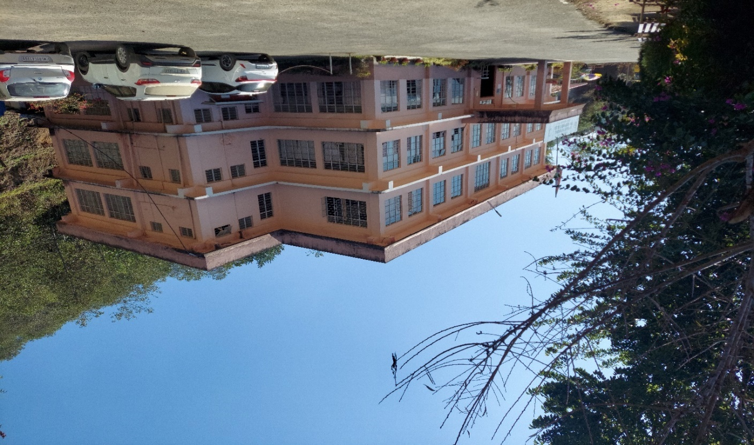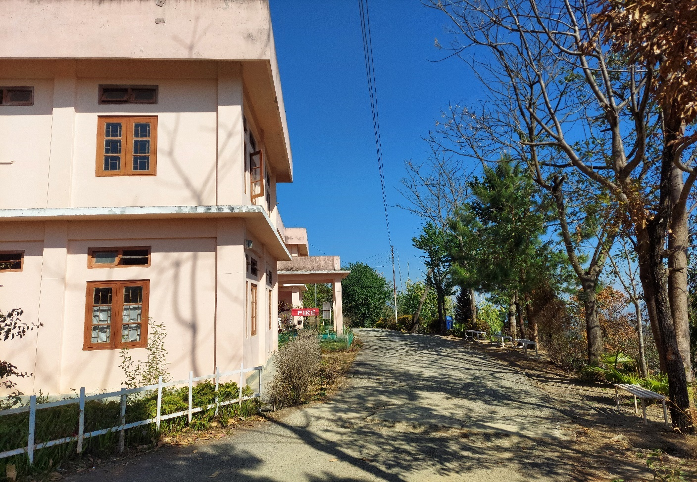

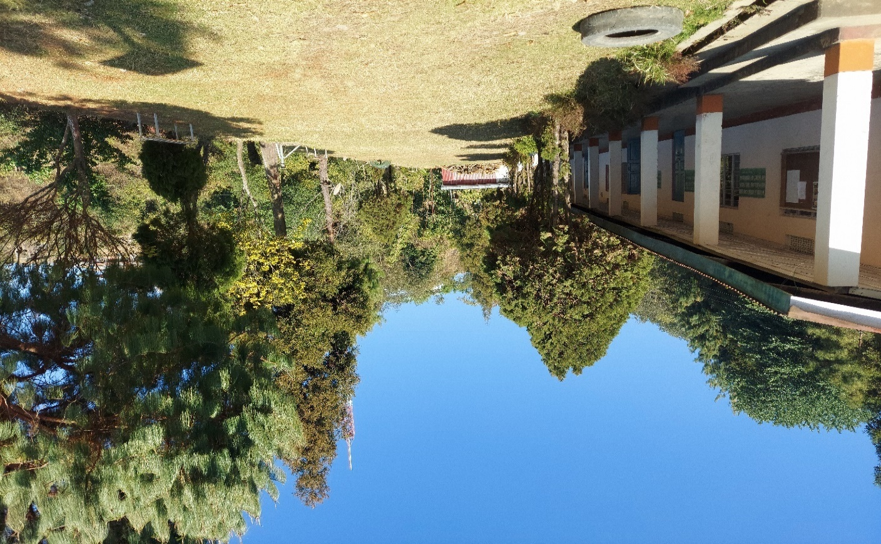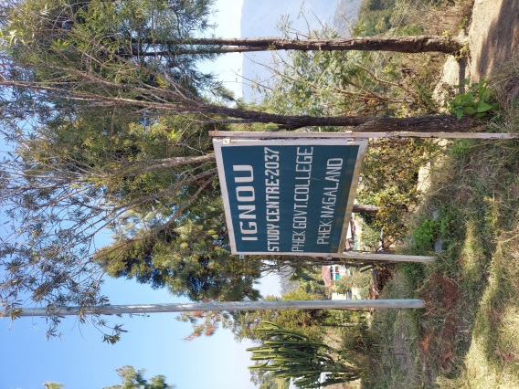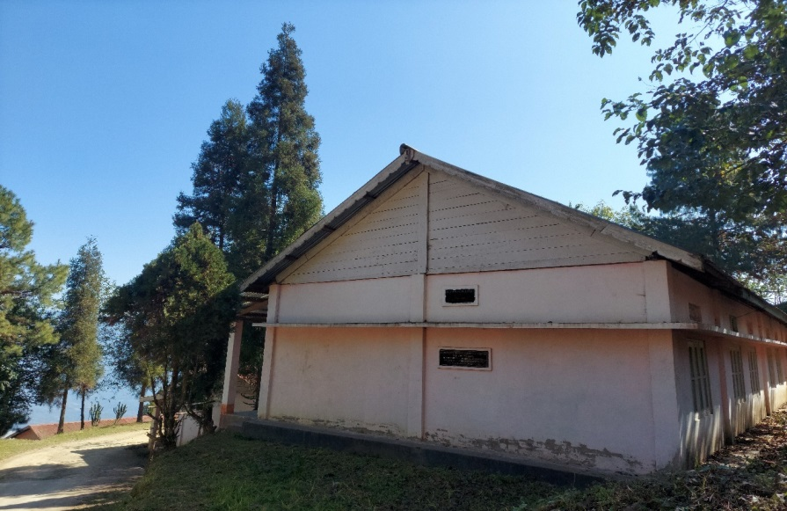

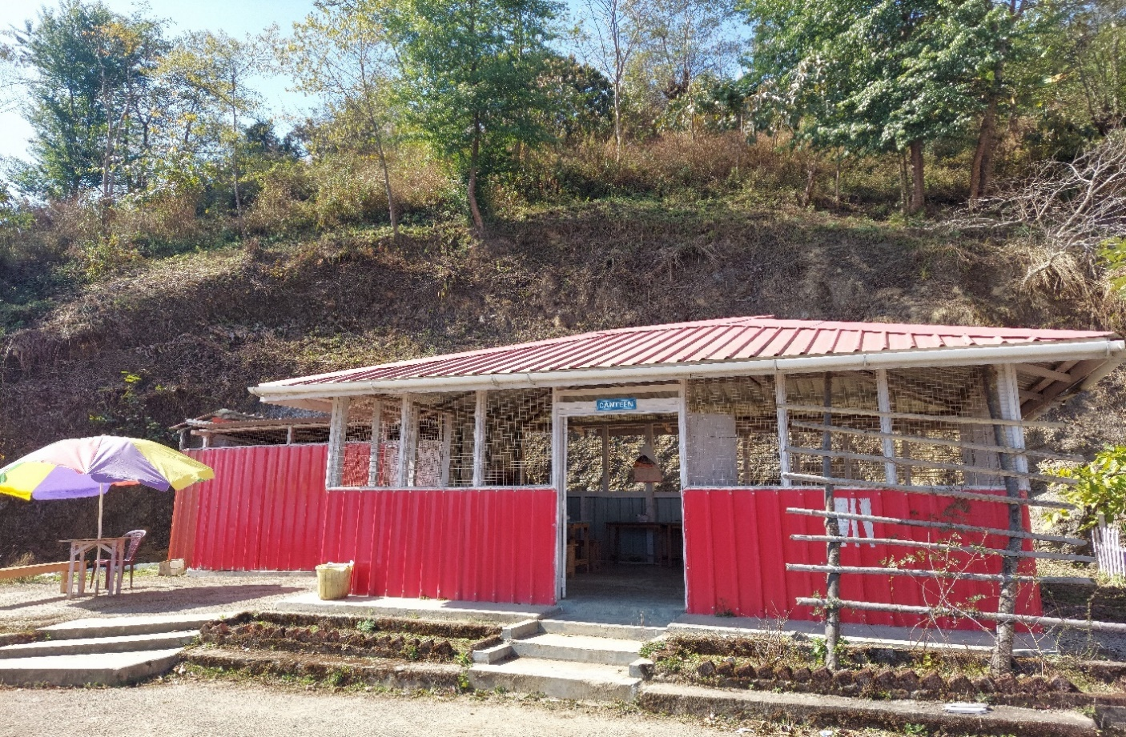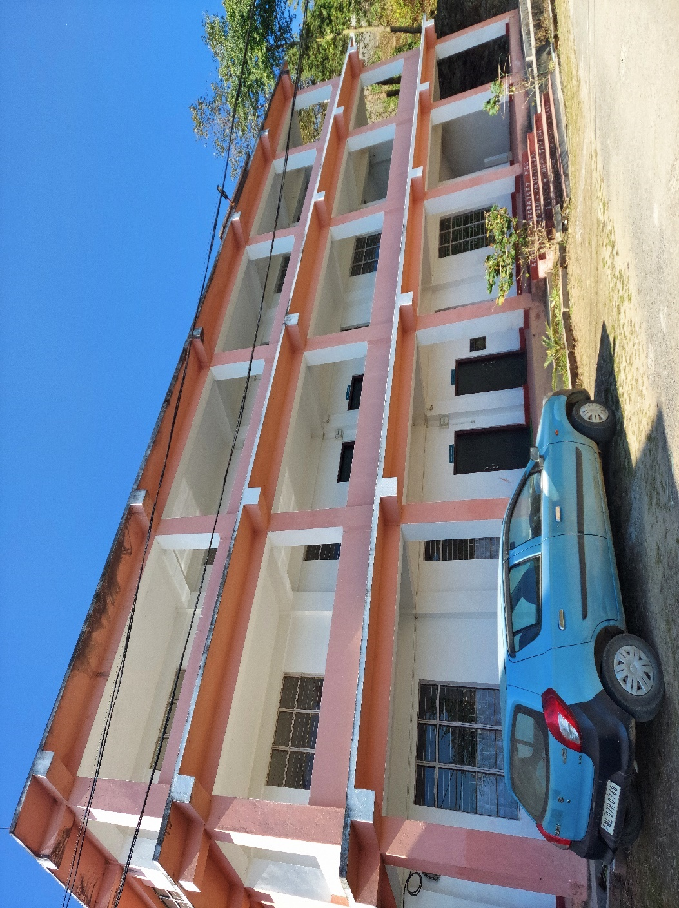

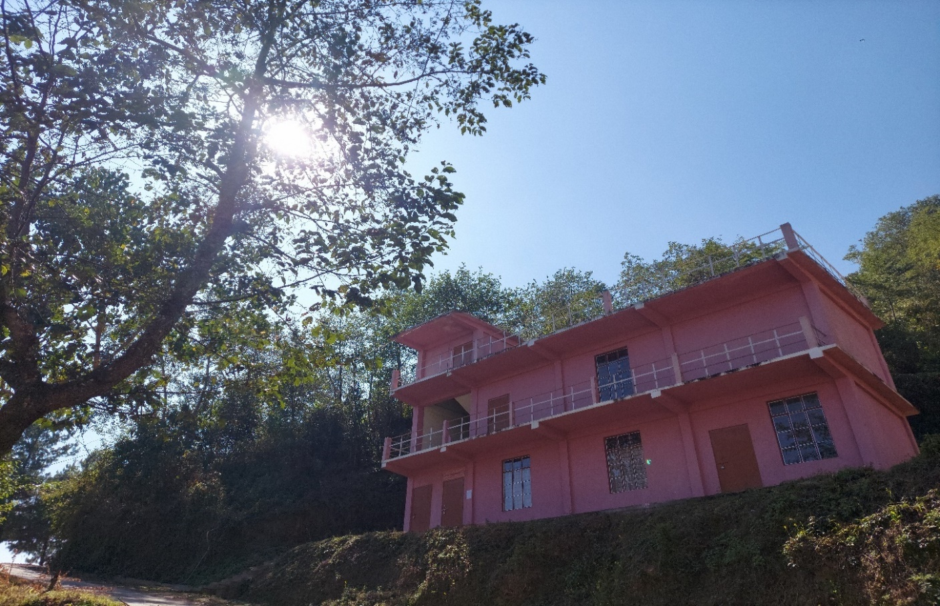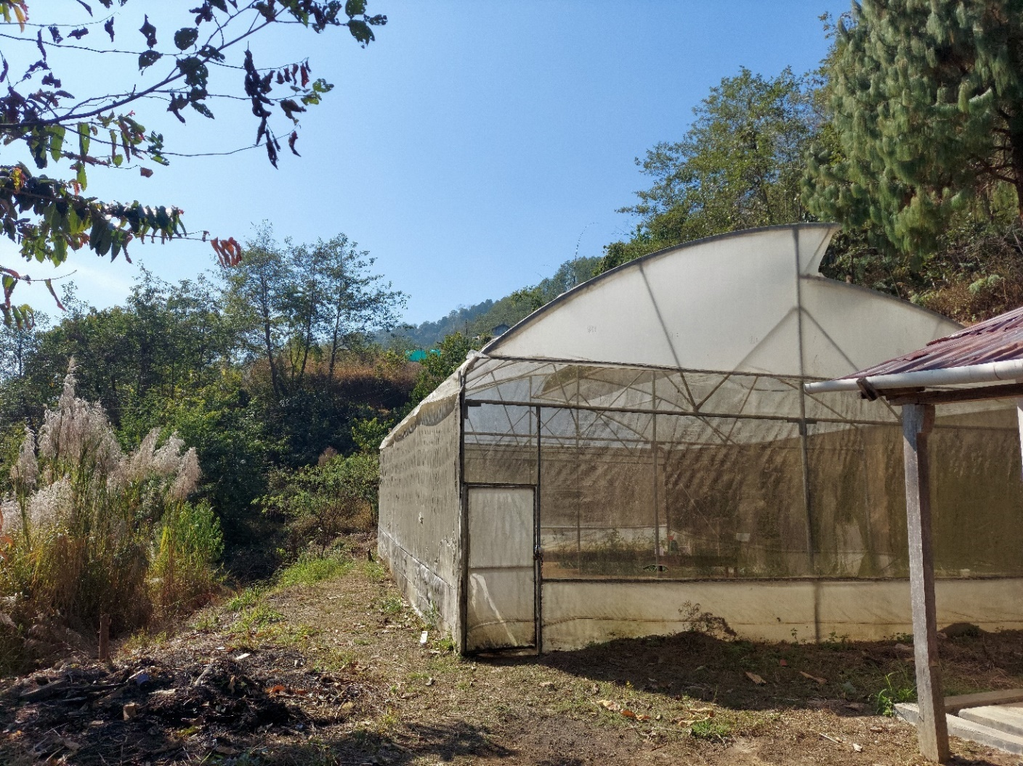
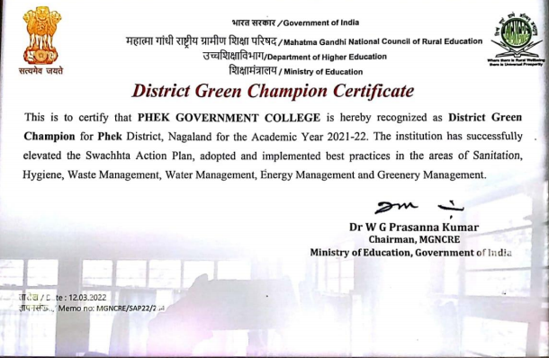

- GREEN PRACTICES:

  - COLLEGE BEST PRACTICE:
The college practices a teacher-student synergy for a green campus. Under this initiative, both teachers and students take active participation and are co-partners in maintaining a green campus. The Eco & Sanitation Club oversees activities related to this practice. A few teachers along with several students from each semester are divided into groups and assigned to specific plots located within the campus. Each group work on developing and beautifying their plots by planting flowers, shrubs, tree. This practice promotes mutual sense of responsibility and accountability.
Students are also assigned into different groups to maintain cleanliness and hygiene in their classrooms and toilets. Daily cleanliness routine and charts are prepared by the Eco & Sanitation and the club regularly monitor this activity.
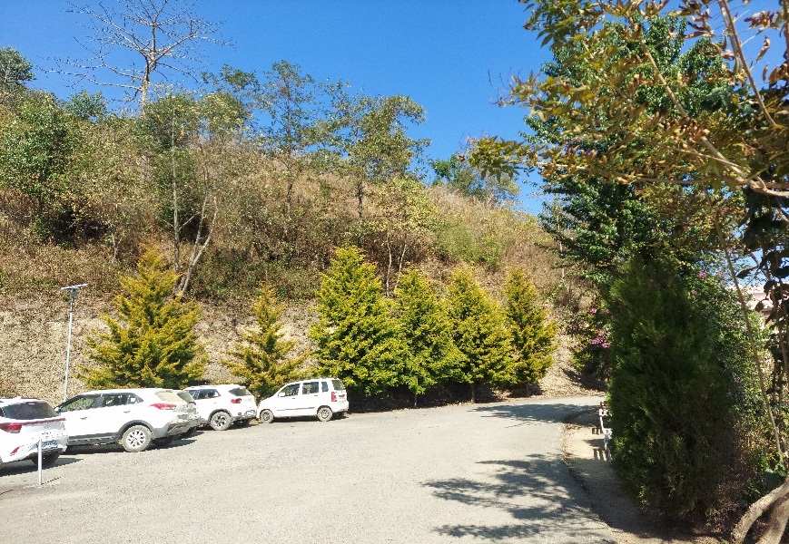

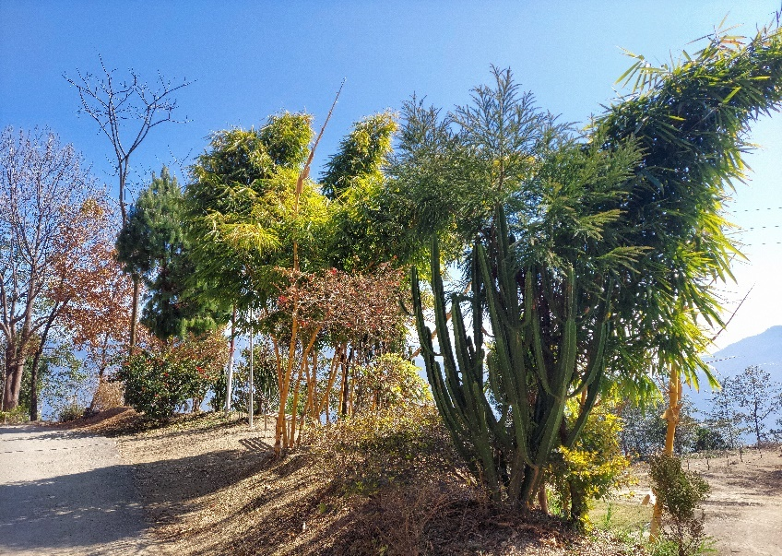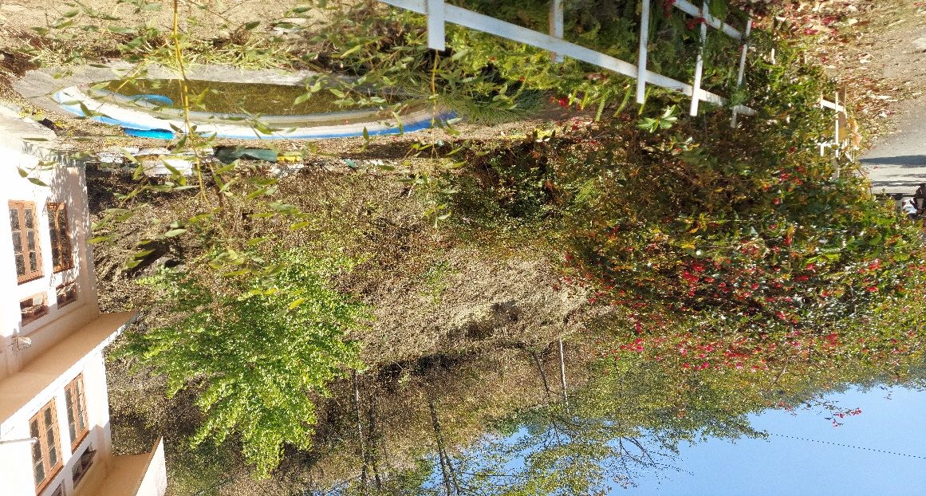
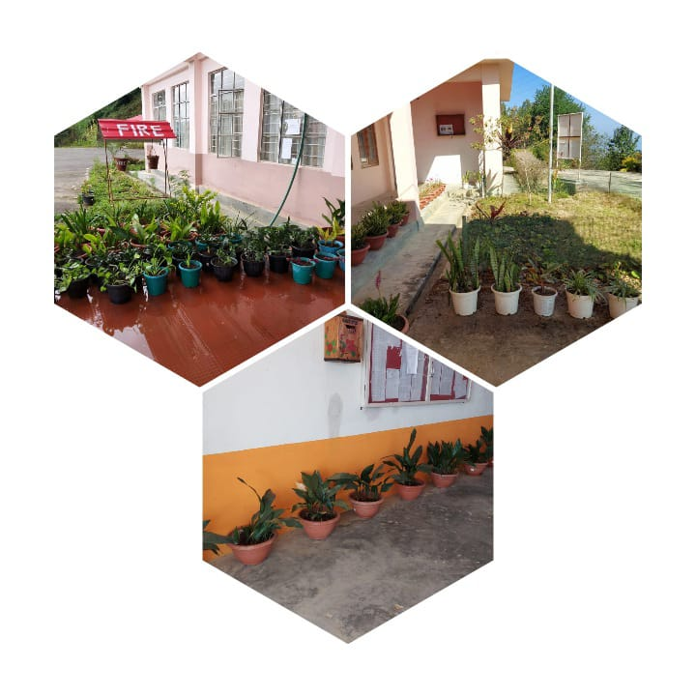

  - BEST PRACTICE OF BOTANY DEPARTMENT:
The bulletin Campus Flowers is issued by the Department of Botany as its best practice. The main objective behind this initiative it to give an insight of the campus flora. The faculty of Botany Department along with the students collaboratively contribute in identifying flowers in the campus and publish it monthly. This practice has garnered ample attention and interest among the students and teachers from other departments as they get to know and learn different flowers every month.
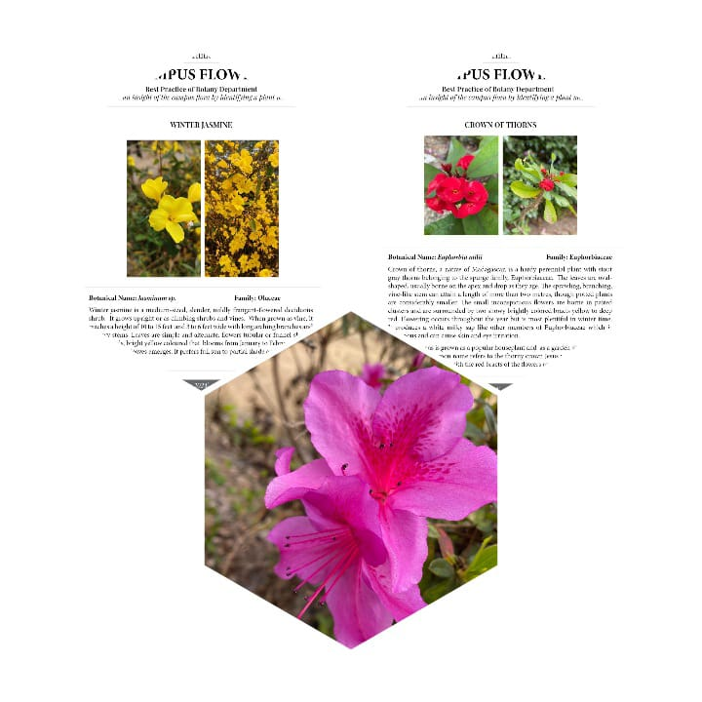

- ACTIVITIES CONDUCTED FOR GREEN CAMPUS
(2019-2023):
The following activities were undertaken for green campus:
- Mass social work was conducted for three consecutive days on 8th, 9th & 11th February, 2019 in preparation for NAAC assessment.
- Mass social work was conducted on 18th May, 2019.
- On 13th October, 2021, the students of Phek Government College engaged in social work in collaboration with Nehru Yuva Kendra, Department of Youth Affairs, under the theme “Clean India”.
- On 14th October, 2021, the institution along with a local organization, Phek Town Chakhesang Students Union, participated in a sanitation drive in Phek Town.
- A field study trip-cum-cleanliness drive was organized by the teachers and students of environmental studies of the college, in Mt. Kapamodzu, Phek district, on 26th August, 2021. The main purpose of the trip was to study the vegetation and to create awareness about the importance of conservation of environment and ecotourism.
- Eco and Sanitation Club planted fifty evergreen plants in the campus on 11th August, 2021.
- On 2nd March 2022 as per the directives given by the Phek Town Council on assessment for Cleanest Educational Institute under its jurisdiction, the Eco & Sanitation club set up a Waste Management Committee comprising of six student members and a student Brand Ambassador to Phek Town Council on Waste Management, to sensitize students on ‘My Waste My Responsibility’.
- The Eco & Sanitation club on 22/03/2022 allocated plots for Teachers and Students for the current semester as a fulfillment for Institution’s Best Practice.
- On 23/03/2022 the college organized a mass social work in the college.
- Phek Town Council and administrators organized an awareness program on Waste Management on 4th March, 2022 in the college premises.
- On 23rd April, 2022, the college participated in the PTCSU 18th Sanitation phase from clock tower to local ground, Phek town, under the banner “One strength, One Voice.”
- On 5th May, 2022, 8th July, 2022, and 29th October 2022, the college organized mass social work days.
- On 8th August, 2022, a mass social work was conducted as per the directive of the District Administration, in commemoration of 75th year of India’s Independence.
- Mass social work on 07/05/2022 on account of preparation for Nagaland University Inspection for permanent affiliation of the college.
- The Eco & Sanitation club members on 09/05/2022 potted evergreen plants at the administrative block.
- On 4th June, 2022, the college participated in mega tree plantation drive commemorating the World Environment Day under the initiative of the District Administration, Phek.
- Mass social work in the college and Boys hostel area on 08/08/2022.
- On 26th August 2023, the Department of Environmental Studies, Arts and Science streams organised a field study trip-cum-cleanliness drive at Mt.Kapamodzu.
- Phek Government College, in collaboration with NIT Nagaland and GB Pant National Institute of Himalayan Environment, Uttarakhand, sponsored by National Commission on Himalayan Studies conducted a one-day workshop on “Sensitization and Developing a Cadre of Para-hydrologist on Spring-Shed Management” on 31st August, 2022.
- Mass social work for clearing the Girls hostel, Principal and staff quarter surrounding on 29/10/2022.
- On 9/02/2023, the Eco & Sanitation club brought out a notice for students on daily cleanliness routine
- As per the directive from the Hon’ble Minister of Higher Education & Tourism Nagaland dated 1st April 2023, the club on 13/04/2023 appointed a teacher in-charge and two students as ‘Clean & Green Campus Ambassadors and submitted their bio-data to the Directorate of Higher Education.
- Mass social work organised on 18/04/2023 on account of the Governor’s visit to the college.
- Commemorating the World Environment Day on 5/06/2023 a plantation drive was organised in the campus with faculty, staff, and students’ executives. Altogether 100 trees saplings were planted in the campus.
- On 19/07/2023 a mass social work was conducted along with faculty, students, and staff.
- On 11th Aug, 2023 the college observed Meri Maati Mera Desh.
- An awareness programme on Mission Life under National Clean Air Programme (NCAP) was conducted on 19th Sept, 2023.
- A mass social work was conducted on 15th Nov, 2023 on account of Academic and Administrative Audit peer team visit to the college.

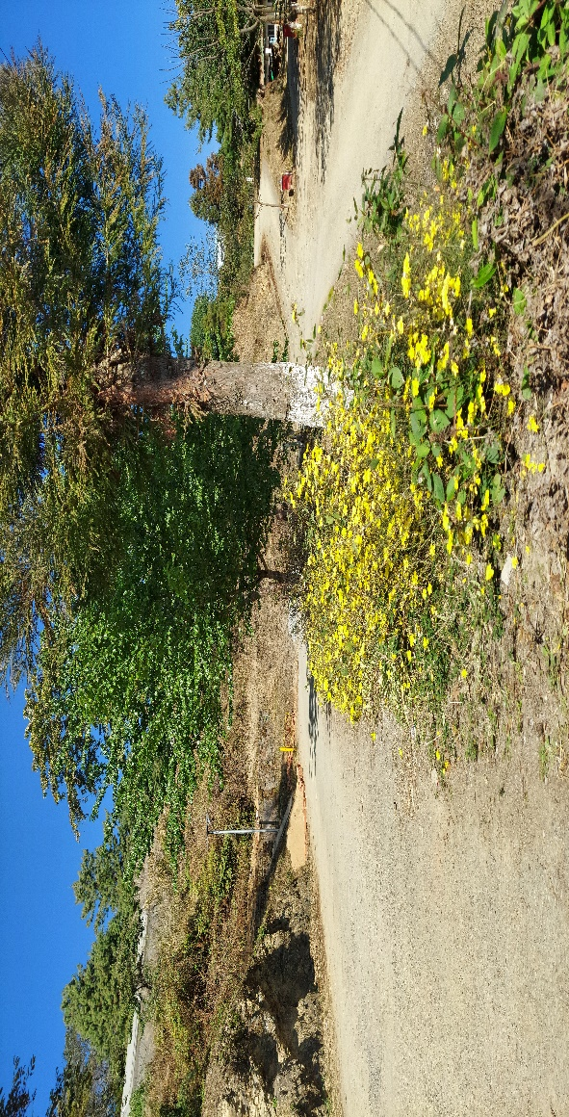
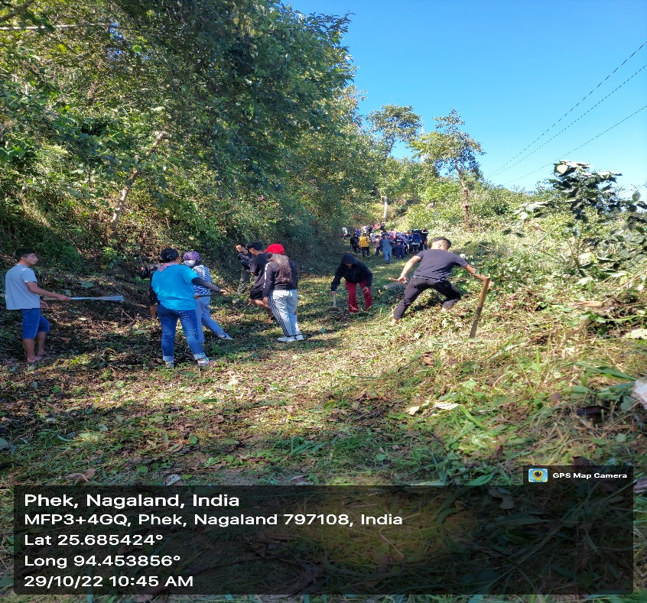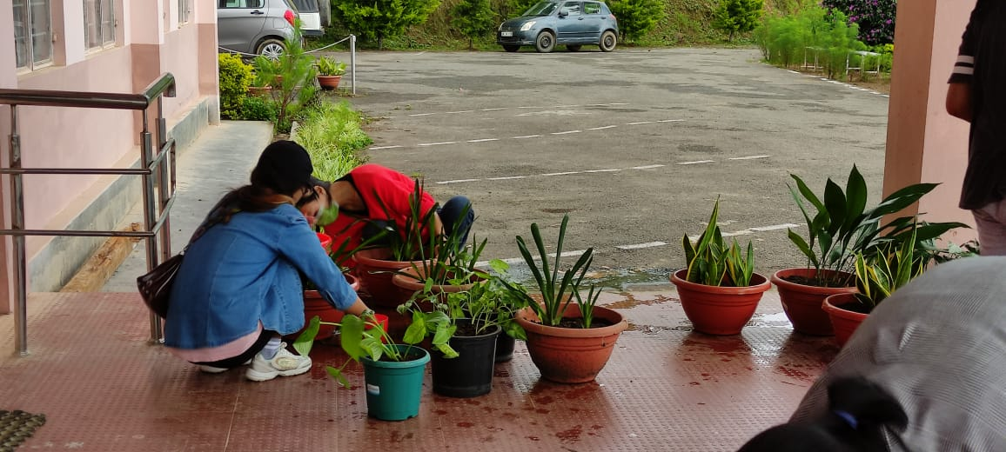

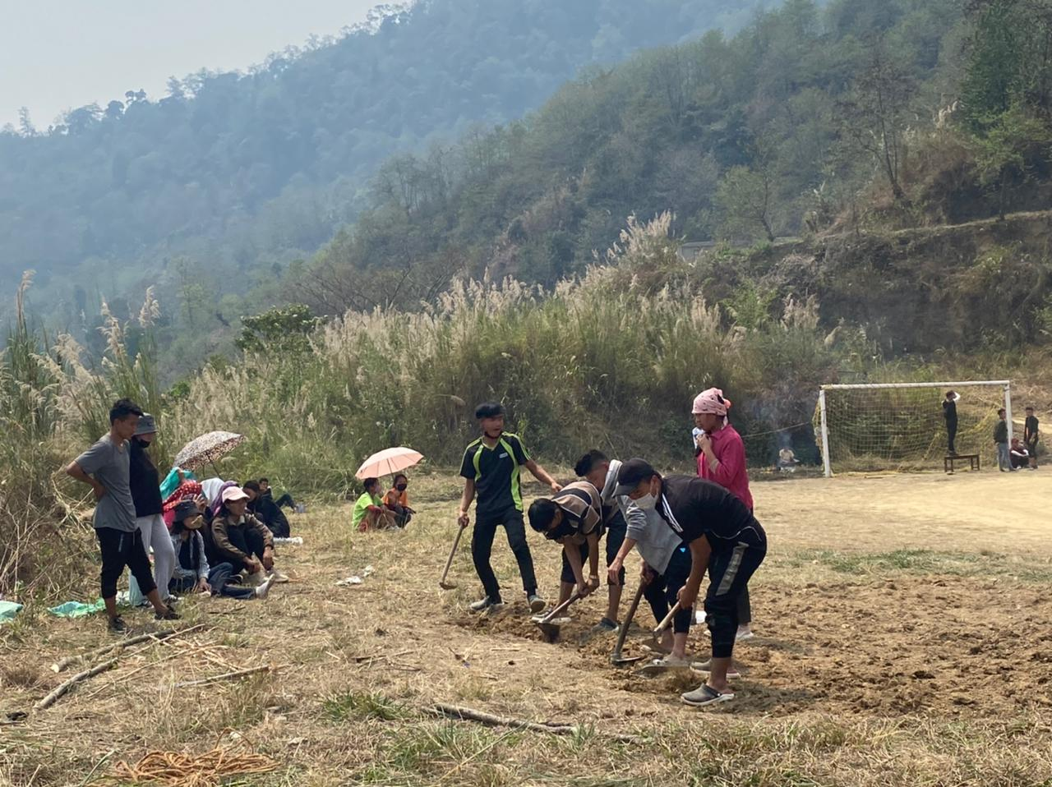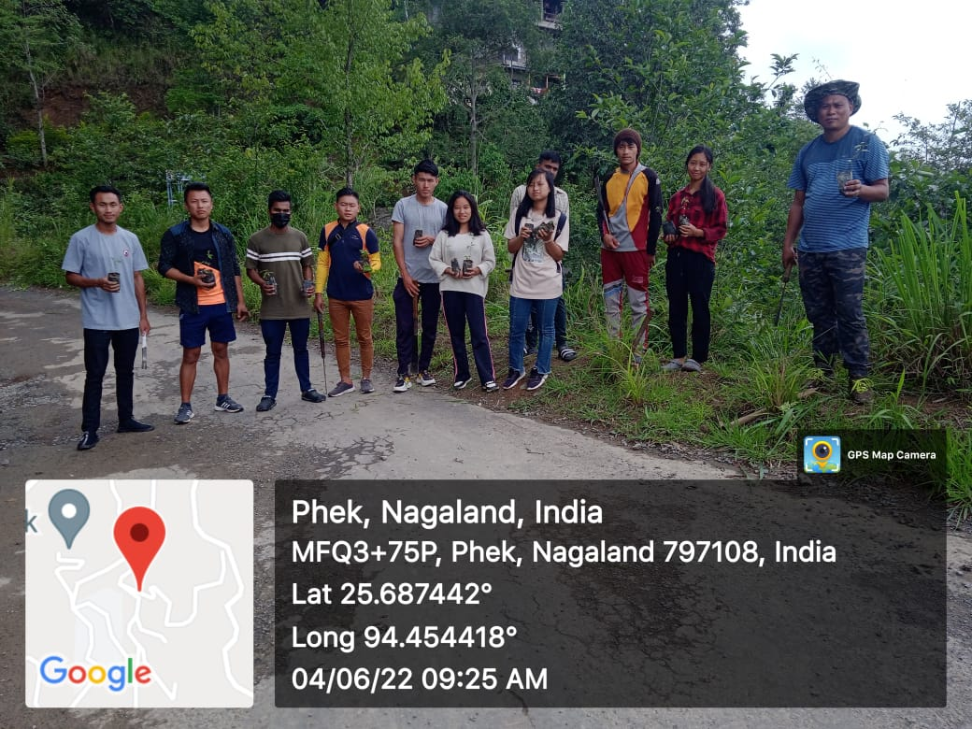
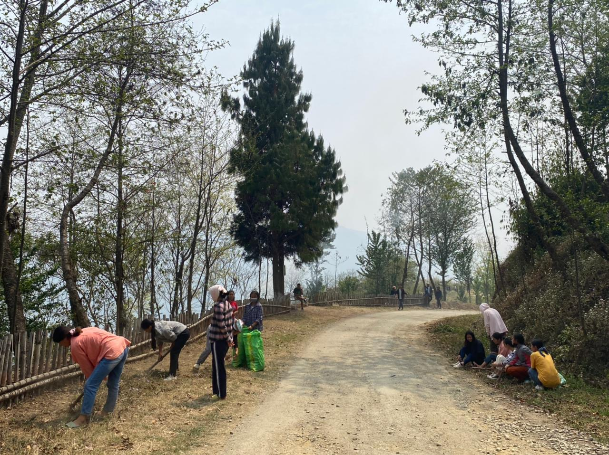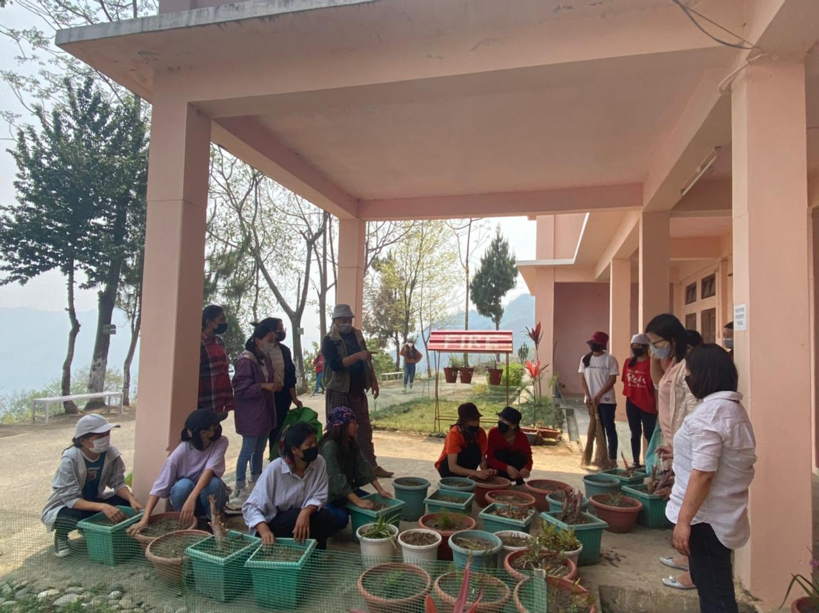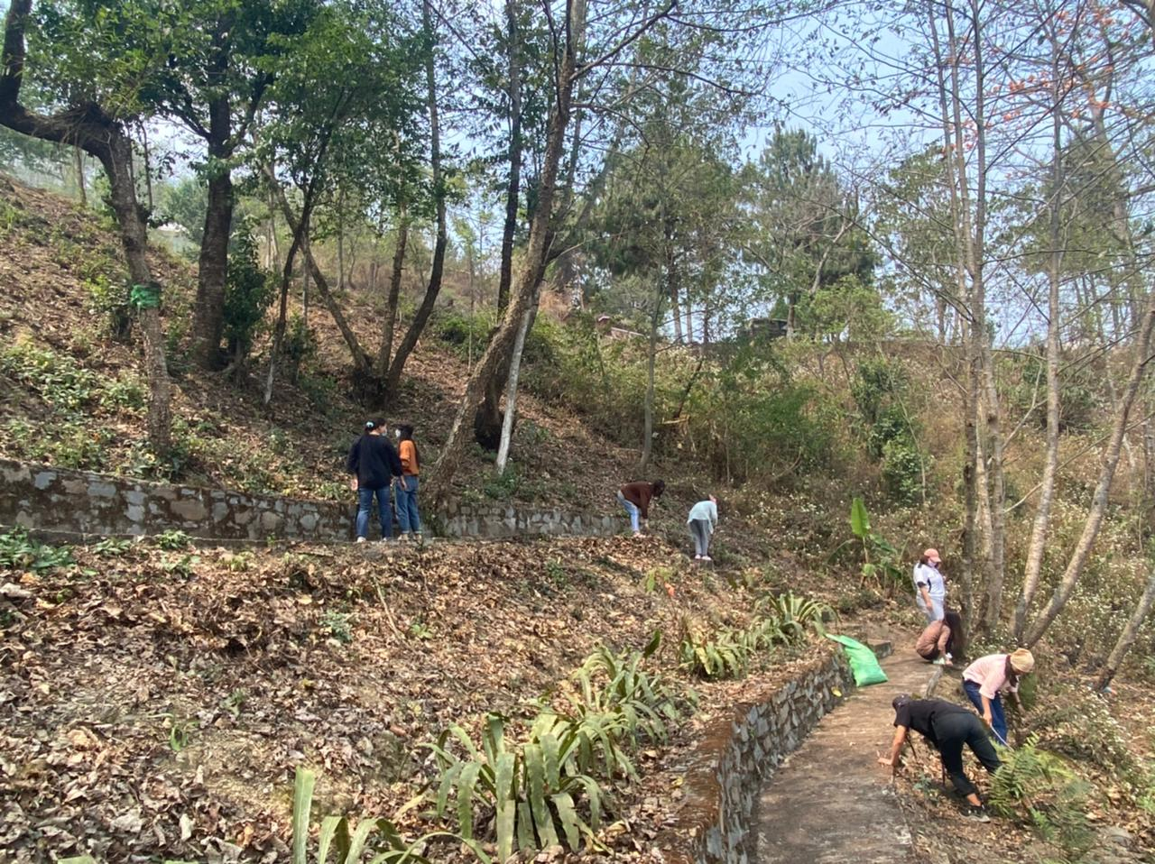

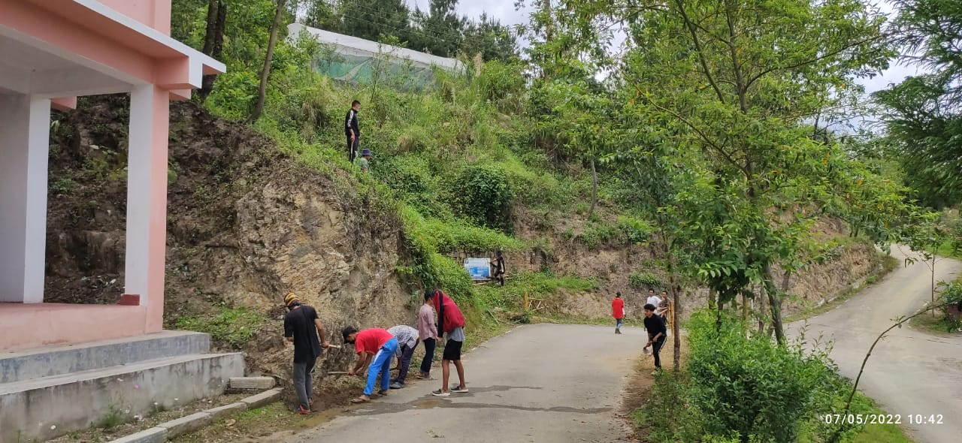

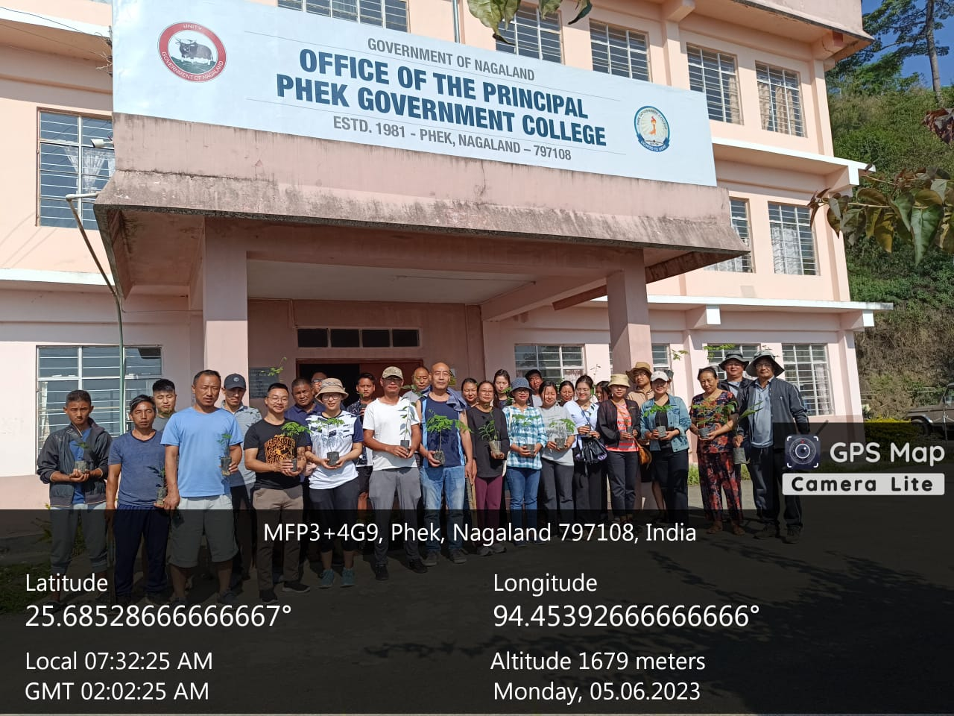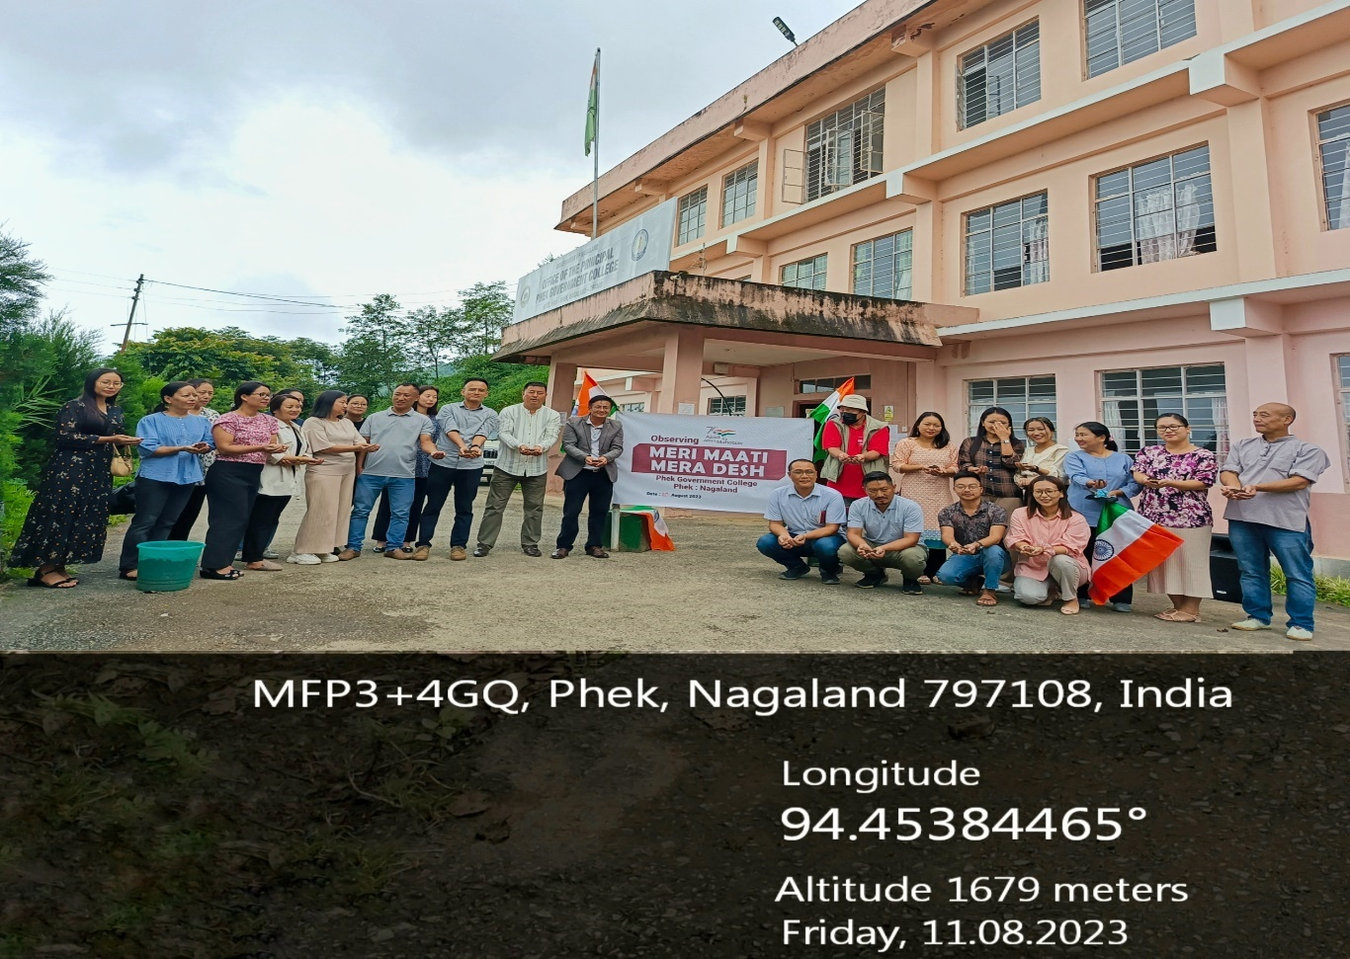

GREEN AUDIT
PHEK GOVERNMENT COLLEGE
- List of flora in the college campus:
SL. NO. | SCIENTIFIC NAME | COMMON NAME | FAMILY | DETAILS OF THE PLANT | APPROX. NO
NATIVE PLANT SPECIES

 | Abelmoschus moschatusMedik. | Wild Ladysfinger | Malvaceae | A perennial bearing hibiscus-like yellow coloured flower | 5
 | Aegopodium podograria | Ground elder | Apiaceae | A herbaceous perennial growing from rhizomes producing umbel inflorescence in white with ternate toothed leaves.
 | Aeschynanthus sp. | Blushwort | Gesneriaceae | A perennial dwelling on trees with hanging stem and red flowers.
 | Ageratum conyzoides L. | Devil's cotton | Asteraceae | A perennial with a fluffy head inflorescence of lavender -blue, lilac or white spread in small compound umbel
 | Albizzia lebbeck (L) Benth. | Silk tree | Fabaceae | A tree growing up to a height of 18-30 cm, with white flower that has numerous 2-3.8 cm long stamens and are fragrant.
 | Alnus nepalensis D. Don. | Alder tree | Betulaceae | A. large deciduous tree with silver-grey bark that reach up to 30 m, flower catkins with male and female flower separate but are produced in same tree. | 1
 | Artimisia vulgaris L. | Mugwort | Asteraceae | A perennial with aromatic flowering plant of Asteraceae family
 | Bambusa sp. | Bamboo | Poaceae | A tall grass with numerous branches emerging from nodes. | 7
 | Bauhinia sp. | Mountain ebony | Fabaceae | A small to medium sized tree with conspicuous, bright pink-white flower. | 8
 | Bidens pilosa L. | Beggar's tick | Asterceae | A annual herb with small head flower borne on long peduncle with 4-5 white ray floret and many tubular yellow disc florets without ligule
 | Bombax ceiba L. | Silk cotton tree | Malvaceae | A large tree reaching up to 30-40 m in height bearing a red flower while the tree is leafless. | 5
 | Cassia sp. | Golden shower | Fabaceae | A woody perennial, flowers borne in raceme, Petal light yellow, cup shape bract. | 2
 | Chrysopogon sp. | Spear grass | Poaceae | A perennial plant bearing dark seed with a single awn at one end and a sharp spike at the other
 | Citrus sp. | Orange | Rutaceae | A shrubby tree with many thorns, flower pleasantly perfume, yellowish-white in colour. | 5
 | Crassocephalumcrepidiodes | Gynura | Asteraceae | A thickhead annual herb, flower head in cymes, cylindrical, green with red florets on top, seeds floating balls of numerous silky white hairs.
 | Cuphea sp. | Waxweed | Lythraceae | A perennial herb erect or spreading, glandular -velvet- hairy and bristly, flowers are small borne in short monochasial cyme or sometimes solitary in the axil leaves.
 | Diospyros peregrine (Gaertn.) Gurkre. | Wild persimmon | Ebenaceae | A evergreen tree, cymes male and solitary female flower with yellow fruit when ripe. | 3
 | Docynia indica | Wild apple | Rosaceae | A small to medium sized tree belonging to the family Rosaceae with white flower, prickles barks and a pome fruit.
 | Drymaria cordata | Chickweed | Caryophyllaceae | A prostrate heard with dichotomous branching, leave ovate, almost round, with heart shaped base, flower tiny, borne in cyme, sepal lance shaped, Petal white. | 5
 | Elaeagnus sp. | Silver berry | Elaeanaceae | A woody climber, covered with silver scales, flowers greenish-white, fruit berry.
 | Emblica officinalis | Indian gooseberry | Phyllantaceae | A small to medium sized deciduous tree reaching 8 to 18 m in height, leaves simple nearly stalkless, crooked trunk, flower small greenish-yellow or pinkish, fruit spherical, light greenish yellow. | 5
 | Equisetum arvense L. | Horsetails | Equisetaceae | A perennial bearing a cone-like strobilus. The leaves are arranged in whorls fused into nodal sheaths.
 | Eupatorium adenophorumSpreng. | Crofton weed | Asteraceae | A perennial shrub bearing a small compound flower that are creamy white and each small flower followed by a small brown seed. | 3
 | Fagopyrum tartaricum (L.) Gaertn. | Common buckwheat | Polygonaceae | An annual flowering plant with red stem and white and pink flower.
 | Ficus prostrata Wall. ex Roxb. | Fig | Moraceae | A small to medium tree with greyish brown bark, figs borne on pendulous, brick red at maturity.
 | Ficus semicordata Buck. Ham. ex Roxb. | Drooping fig | Moraceae | A small to medium sized tree with pendulous branches and often prostrate on the underground, fruit pink or dull reddish brown. | 2
 | Galinsoga sp. | Gallant soldier | Asteraceae | A slender annual herb, leaves ovate, flower head, white florets, fruit achenes.
 | Houttuynia cordataThunb. | Fish mint | Saururaceae | A herbaceous perennial with a broad heart-shaped leaves, flower greenish yellow borne on a terminal spike along with white petal-like bracts.
 | Impatiens arguta | East Himalayas Balsam | Balsaminaceae | A wildflower perennial plant, erect stems are rigid and branched, flowers arise singly or doubly in leaf axils, pink or purpled- red Petal, sac like lower sepal. | 2
 | Impatiens sp. | Garden balsam | Balsaminaceae | An annual plant with soft stem, leaves broad, with deeply toothed margin, flowers pink, red, mauve, purple, white, lilac, characterised lower lobe of lateral petals being divided into two, upper Petal circular, lower sepal sac- like. | 5
 | Imperata cylindrica | Common thatching grass | Poaceae | A perennial rhizomatous grass, flowers borne in conspicuous cylindrical silky spike 1-16 long, individual flower spikelet with two stamens and two feathery stigmas.
 | Juglans regia | Common Walnut | Juglandaceae | A large deciduous tree reaching a height of 25-30m, bark smooth and silvery-grey, Male flower in drooping catkins and female flowers are terminal in clusters of two to five
 | Litsea citrate Blume. | Mountain pepper | Lauraceae | A deciduous shrub or small tree with silky branches, flowers borne in cluster/solitary and cream in colour.
 | Litseaglutinosa (Lour.) C. B. Rob. | Soft bollygum | Lauraceae | an evergreen or deciduous tree with yellowish flower borne in solitary or cluster.
 | Melastoma sp. | Melastoma | Melastomaceae | A shrub growing up to 5m with broad lance-like leaves, flower pinkish-mauve and hairy sepals | 5
 | Melia azadirachta L. | China berry | Meliaceae | Evergreen tree, flower small, fragrant, pale purple or lilac, growing in cluster. | 2
 | Musa sp. | Banana | Musaceae | A monocarpic gigantic herb with pseudo aerial stem, long and broad leaves. Inflorescence spadix with a large, brightly coloured bract called spathe. | 3
 | Oenothera sp. | Evening primrose | Onagraceae | A perennial with velvet stems, produces single, four- petals, white to pink colour, cup-shaped flower on the upper axils. | 5
 | OsbeckiacrinitaBenth. | Hairy osbeckia | Melastomaceae | A hairy shrub up to 2.5m tall branches covered with spreading bulb based fuscous hairs, flowers purple in colour.
 | Oxalis | Wood sorrel | Oxalidaceae | A creeping wood sorrel, single flower, petals yellow, fruit capsule. | 3
 | Passiflora foetida | Wild passion fruit | Passifloraceae | A climber, flower white to pale cream, fruit mature yellow colour. | 7
 | Passiflora indica | Passion fruit | Passifloraceae | A climbing vine, clings by tendrils, single flower, sepal greenish-white, Petal white, finger like corona, white tipped rays, rich purple base, triple branched style, fruit dark purple when ripe.
 | Persicaria capitata | Pink knotweed | Polygonaceae | A mat forming perennial herb, stem prostrate sometime rooting at node, elliptic ovate leaves, flower light to dark purple, head-like spikes at the end of the branches. | 1
 | Persicarianepalensis | Knotweed | Polygonaceae | A annual herb with simple branched, terminal corymbs inflorescence, flowers tiny, light pink-blue.
 | Plantago sp. | Common plantain | Plaintaginaceae | A herbaceous perennial plant with a rosette leaves that is oval with acute apex, flower small, greenish-brown with purple stamens produced in a dense spike.
 | Polygonum sp. | Knotweed | Polygonaceae | A perennial herb with pinkish or white flower borne in dense and rounded cluster.
 | Pouzolzia sp. | Graceful pouzolzia (nettle family) | Urticaceae | A perennial herb, leaves lance shaped-rhomboid ovate, flower pale green, in loose leaf axils cluster.
 | Prunus persica | Peach | Rosaceae | A low, broad tree with dark green, lanceolate, deciduous leaves, flowers produce in solitary or paired, Petal five and pink, fruit stone type (drupe).
 | Quercus serrata | Jolcham Oak | Fagaceae | A deciduous tree reaching a height of 25m with grey or reddish bark, leaves elliptical in shape with serrated margins, pistillate inflorescence.
 | Rhus semialataMurr. | Nutgall tree | Anacardiaceae | A shrub to small tree of 2-10 m in height, flowers borne in many branches cluster densely rusty velvet- hairy, male flower longer than female, white or pale yellowish-green in colour. | 3
 | Rubus idaeus L. | Raspberry | Rosaceae | A tall scrambling shrub or climber, stem covered in short rusty/white woolly hairs and numerous recurved prickles. Flowers white borne in cluster on upper leaf axils, fruit bright red berry.
 | Rumex patienta | Sorrels | Polygonaceae | A perennial herb with stout erect stem, with oblong -lance shaped leaves, flowers small yellowish-green, in whorls arranged in numerous spike -like cluster. | 1
 | Sonchus | Sow thistle | Asteraceae | A perennial herb, tuft radical tuft leaves, flowers head, umbellately corymbose, florets bright yellow.
 | Thysanolaena maxima (Roxb.) Kuntze. | Nepalese broom grass | Poaceae | A bamboo like perennial grass growing up to 2 m tall, forming large clumps. Flowers minute spikelet, in large branches cluster.
 | Urena sp. | Urena | Malvaceae | A pantropical weed, having pink flowers like miniature hollyhocks.
NON-NATIVE PLANT SPECIES

 | Achillea alpina | Alpine Yarrow | Asteraceae | A perennial herb with white flowers, linear-oblong leaves with sharp teeth and stem covered with cobwebby hairs.
 | Agapanthus africanus | African lily / blue lily | Amaryllidaceae | A perennial herb of short stem bearing tuft of long, narrow leaves and bright blue or purplish umbel flowers. | 5
 | Ajuga sp. | Basil Bugle weed | Lamiaceae | A perennial herb with prostrate stem with blue or purple colour flowers.
 | Aloe vera | Aloe | Asphodelaceae | A perennial invasive succulent species with thick fleshy leaves having white flecks on its upper surface and serrated margin with teeth. a medicinal plant used for healing burns and acidity.
 | Amaryllis sp. | Easter lily | Amaryllidaceae | A bulbous plant with strap-shaped leaves producing big showy red coloured flowers. | 5
 | Anemone hupehensis | Japanese Anemone | Ranunculaceae | A perennial shrub bearing white colour flowers grown as ornamental.
 | Barberis | Barberry | Berberidaceae | A small tree with thorny leaves that turns red during the winter season. | 1
 | Bougainvillea sp. | Bougainvillea | Nyctaginaceae | An evergreen climbing shrub with thorny stems and drooping branches producing tiny flowers surrounded by large colourful papery bracts. | 8
 | Callistemon sp. | Bottle brush | Myrtaceae | A small and slow growing ornamental tree with red flowers that resemble like a bottle brush. | 7
 | Camellia sp. | Camellia | Theaceae | A slow growing shrub with rose like flowers whose petals are many layered. | 2
 | Chlorophytum comosum | Spider plant | Asparagaceae | A herbaceous perennial spider-like plant with tuberous roots and narrow long variegated leaves.
 | Coixlacryma-jobi | Job's tears | Poaceae | A grain bearing perennial grass cultivated for its grains with a hard shell.
 | Cosmos bipinnatus | Cosmos, Mexican aster | Asteraceae | An annual herb with feathery or lacy foliage and showy pink, maroon or white flowers.
 | Cosmussulphureus | Orange cosmos / Sulphur cosmos | Asteraceae | An annual herb with pinnately compound leaves with orange or yellow colour flowers.
 | Crocus sp. | Crocus | Iridaceae | A perennial growing from corms with linear leaves and purple colour flowers that become dormant after flowering.
 | Cryptomeria japonica | Cryptomeria | Cupressaceae | A large coniferous evergreen tree growing up to 70 m tall grown for as ornamental. | 5
 | Dianthus sp. | Sweet williams | Caryophyllaceae | A herbaceous biennial ornamental, inflorescence umbel in shades of pink, red and white with bluish-green tapered leaves.
 | Durantasp. | Duranta | Verbenaceae | A shrub with bright yellowish colour leaves grown for hedges.
 | Erigeron annuus | Annual fleabane | Asteraceae | An annual herb with lance-shaped leaves bearing many small head or capitulum inflorescence with white ray and yellow disk florets.
 | Euphorbia royleana | Euphorbia Danda thorn | Euphorbiaceae | A large cactus-like shrub with stout stem, thick fleshy branches armed with thorns and spoon-shaped leaves.
 | Euphorbia sp. | Euphorbia Crown of thorns | Euphorbiaceae | A succulent shrub with thick fleshy spiny stem bearing red, pink, yellow blooms.
 | Fragaria | Strawberry | Rosaceae | A creeper producing stolonswith fragrant fruits.
 | Gladiolus murielea | Fragrant Gladiolus | Iridaceae | A perennial corm bearing herb with sword-like leaves bearing numerous white fragrant flowers with a maroon blotch in the centre.
 | Gladiolus sp. | Gladiolus | Iridaceae | A perennial corm bearing herb with sword-like leaves with variously coloured flower spikes.
 | Hibiscus sp. | China rose | Malvaceae | A shrub with big bright variously coloured flowers grown as ornamental. | 5
 | Hydrangea macrophyllum | Hydrangea | Hydrangeaceae | A shrub with huge deciduous leaves with blue- or pink-coloured flowers in cluster.
 | Jasminum nudiflorum | Winter jasmine | Oleaceae | A deciduous shrub bearing many yellow-coloured flowers, the flowers appearing on bare stem during the winter.
 | Lagerstroemia sp. | Crepe Myrtle | Lythraceae | A shrub or multi-trunked small tree with mottled surface on stem and branches due to shedding of the bark throughout the year bearing pink crepe-like flowers. | 3
 | Leucanthemum vulgare | English daisy | Asteraceae | A herbaceous perennial with white colour inflorescence.
 | Macaranga sp. | Macaranga | Euphorbiaceae | An evergreen tree grown as ornamental. | 3
 | Mangifera indica | Mango | Anacardiaceae | Edible fruit tree planted during one of the plantation drives organised by the district administration. | 5
 | Melampodium sp. | Butter daisy / Star daisy | Asteraceae | An annual herb with many small yellow, daisy-like flowers with oppositely arranged leaves.
 | Paulownia sp. | Empress tree | Paulowniaceae | A deciduous tree reaching up to 10-25m in height, with large heart-shaped leaves. Flowers produce on panicle 10-30 cm long with tubular purplish white corolla. | 1
 | Phoenix loureiroi | Mountain date palm | Arecaceae | A palm native to lower altitudes of Phek district planted as ornamental in the campus with edible fruits. | 7
 | Pinus kesiya | Khasi Pine / three needle pine | Pinaceae | A coniferous evergreen pine with long needle like leaves grown for timber. | 5
 | Pinus patula | Weeping Pine | Pinaceae | A coniferous evergreen pine with long drooping needle like leaves grown as ornamental. | 3
 | Pleroma urvilleanum | Purple glory | Melastomaceae | A small shrub producing purple colour flowers. | 1
 | Poinsettia sp. | Christmas poinsettia | Euphorbiaceae | A perennial with red, white and pink foliage.
 | Prunus cerasoides D. Don. | Cherry | Rosaceae | Fruit tree with pink flowers, plantation of which prevents soil erosion.
 | Rhododendron sp. | Azalea | Ericaceae | A bushy shrub with pink flowers grown as ornamental.
 | Rosa sp. | Rose | Rosaceae | A woody perennial with stems armed with sharp prickles bearing large and showy flowers in various colours.
 | Sanseveria sp. | Snake plant | Asparagaceae | Stemless plant, leaves ornamental, long and slender with streaks of greyish colour.
 | Tagetuserecta | Marigold | Asteraceae | An annual herb with linear leaves bearing head inflorescence, ray florets yellow to orange colour and disk floret yellow in colour.
 | Taxus baccata L. | English yew | Taxaceae | Planted as ornamental evergreen, reported having compounds with medicinal values | 3
 | Tecoma stans (L.) Juss. Ex Kunth. | Yellow elder | Bignoniaceae | A shrubby ornamental tree bearing bunch of bright yellow colour flowers. | 1
 | Thuja sp. | Golden thuja | Cupressaceae | An evergreen coniferous tree with bright yellow leaves grown as an ornamental. | 5
 | Thuja sp. | Thuja | Cupressaceae | An evergreen coniferous shrubby tree grown as an ornamental.
 | Tithonia sp. | Mexican sunflower | Asteraceae | A perennial shrub with bright sunflower like flowers. | 3
 | Trachycarpustakil | Kumuoan palm | Arecaceae | A fan palm tree endemic to the foothills of the Himalayas grown as ornamental. | 3
 | Valeriana sp. | Indian Vallerian | Valerianaceae | A perennial herb whose rhizome is used as a sedative.
 | Wodyetiabifurcata | Foxtail palm | Arecaceae | A species of palm native to Australia grown as ornamental. | 2
 | Zantedeschia elliottiana | Golden Calla lily | Araceae | Clump forming herbaceous plant with large arrow shaped leaves, white spotted producing spadix inflorescence bright yellow in colour. | 2
 | Zantedeschia sp. | Calla lily | Araceae | Clump forming herbaceous plant with large arrow shaped leaves with white colour spadix inflorescence. | 5

NB: Plants falling under the division Fungi, Bryophytes and Pteridophytes and Family Orchidaceae and Poaceae are not included in the list above; Plants whose approximate number is exceeding 10 are left blank.

5. Name and number of medicinal plants in the college campus:
SL. NO. | COMMON NAME | SCIENTIFIC NAME | FAMILY | APPROXIMATE NO
1 | Valeriana sp. | Indian Vallerian | Asphodelaceae
2 | Aloe vera | Aloe | Plaintaginaceae
3 | Docynia indica | Wild apple | Saururaceae
4 | Emblica officinalis | Indian gooseberry | Equisetaceae
5 | Equisetum arvense L. | Horsetails | Phyllantaceae
6 | Houttuynia cordataThunb. | Fish mint | Valerianaceae
7 | Litsea citrate Blume. | Mountain pepper | Lauraceae
8 | Litseaglutinosa (Lour.) C. B. Rob. | Soft bollygum | Anacardiaceae
9 | Passiflora indica | Passion fruit | Passifloraceae
10 | Plantago sp. | Common plantain | Lauraceae
11 | Rhus semialataMurr. | Nutgall tree | Rosaceae
NB: Plants whose approximate number is exceeding 10 or more than 10 are left blank.

COMPILED BY:
BOTANY DEPARTMENT

- WASTE MANAGEMENT:
The institution is diligently working towards a green campus. Since Phek Town ban single use plastics and is a plastic-free town, the wastes generated in the college is very minimum and most of its solid non-biodegradable wastes are disposed through waste collection by sanitation workers of Phek Town Council at regular intervals. The biodegradable and non-biodegradable wastes are properly segregated for disposal. The biodegradable wastes are collected in compost pits located at two different locations for composting which is later used as manure for gardening and potting plants. Wastebins are placed at different points in the campus and students make use of these bins to dispose wastes. The liquid/solid wastes produced in laboratories like chemical wastes are properly channelized into a pit dug near the laboratory to minimize contamination to environment. The college generates minimum or zero e-wastes as all electronic devices are efficiently operated by staff. The college canteen produces only minimal wastes as it uses steel plates and cups and most of its food wastes/wet wastes are decomposed for manure.

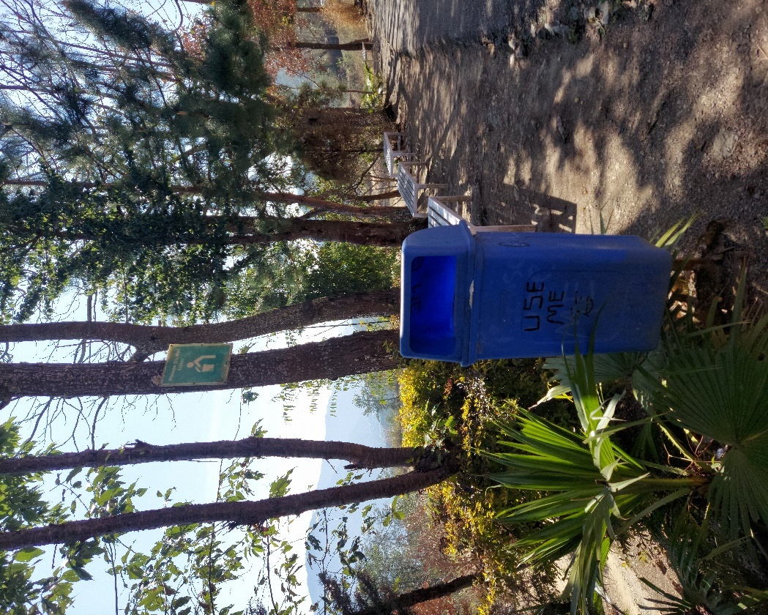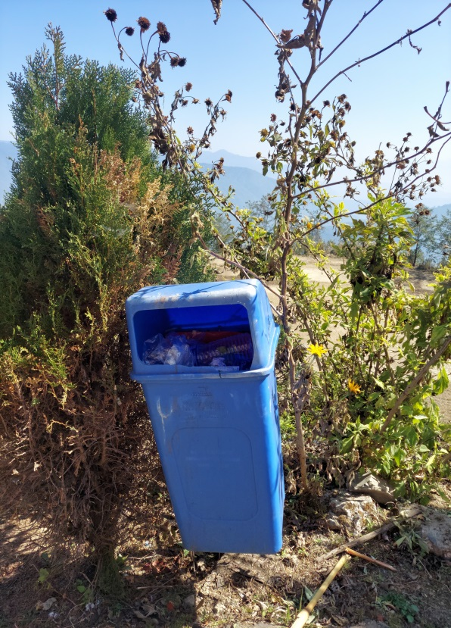

- WATER MANAGEMENT:
The college has two sources of water- spring, and rain harvest. The main spring water source is located 5 kms from the campus which provides sufficient water supply to the college, hostel, and staff quarters. The college has three rain water harvest collection points with a capacity of more than 4000 liters. The rain harvested are used during dry season for watering gardens, toilet use etc.

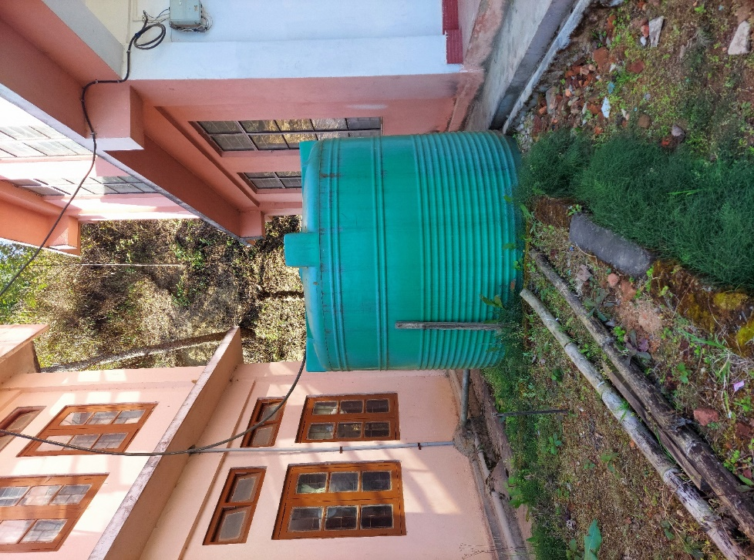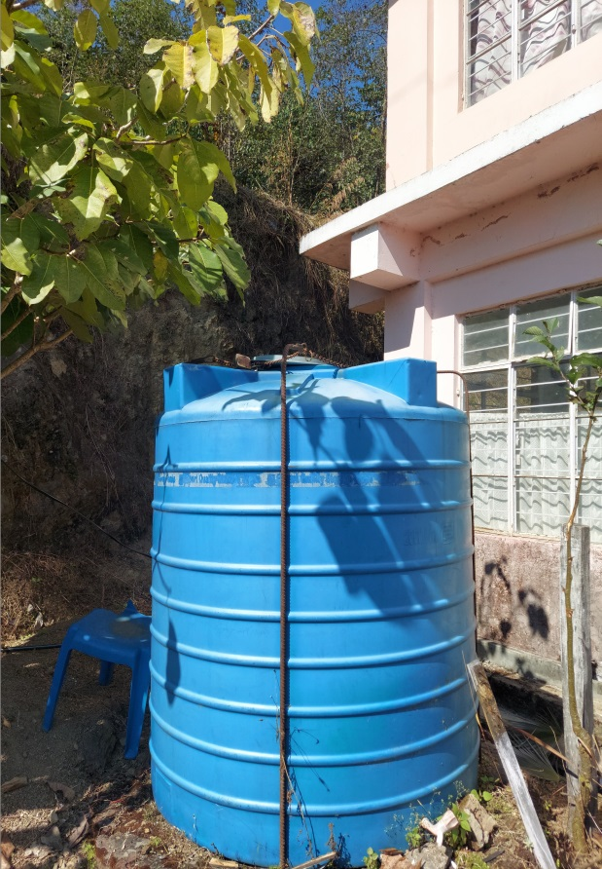

- Conclusion:
The institution’s commitment to work for a greener campus and its initiatives are substantial. Its green practices and students’ awareness are appreciable.
Below are some points the college can take into consideration for improvement;
- The college can come up with a long-term environmental policy for the college.
- A model vermicomposting plant can be established in the campus which can be used a sustainable means for composting biodegradable wastes.
- The college has very few fruiting trees, therefore efforts can be given for plantation of more fruit trees.
- Students and teachers can be encouraged to use cycles to reduce carbon footprints.
- Increasing the number of display boards in on environmental awareness such as ‘save water,’ ‘save electricity,’ ‘no wastage of food/water’ etc. in the campus.
- Exhibitions on waste segregation and recyclable waste products can be conducted for students and staff.

