
PHEK GOVERNMENT COLLEGE
NAAC Accredited ‘B’ Grade
Bible Hill, Phek | 797108- Nagaland

Organization wide awareness and Undertakings on policies with zero tolerance

The college strictly follows the policy of zero-tolerance for ragging, bullying and sexual harassment for students, faculty and staffs. For this purpose, awareness is created through visual posters and notices. At the commencement of the academic session, the College requires students to take a pledge for discipline.

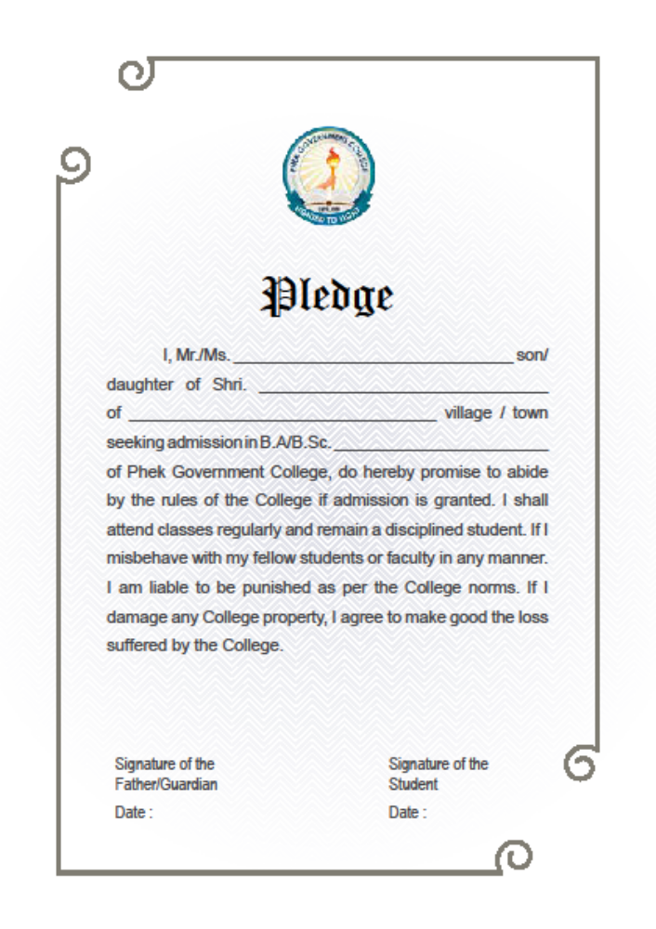

The students are made aware of the general guidelines regarding disciplinary measures, ragging, and harassment outlined in the Prospectus at the time of Orientation which is organized by the College in the beginning of every academic session.

Anti-Ragging and Anti- Harassment Posters in the College

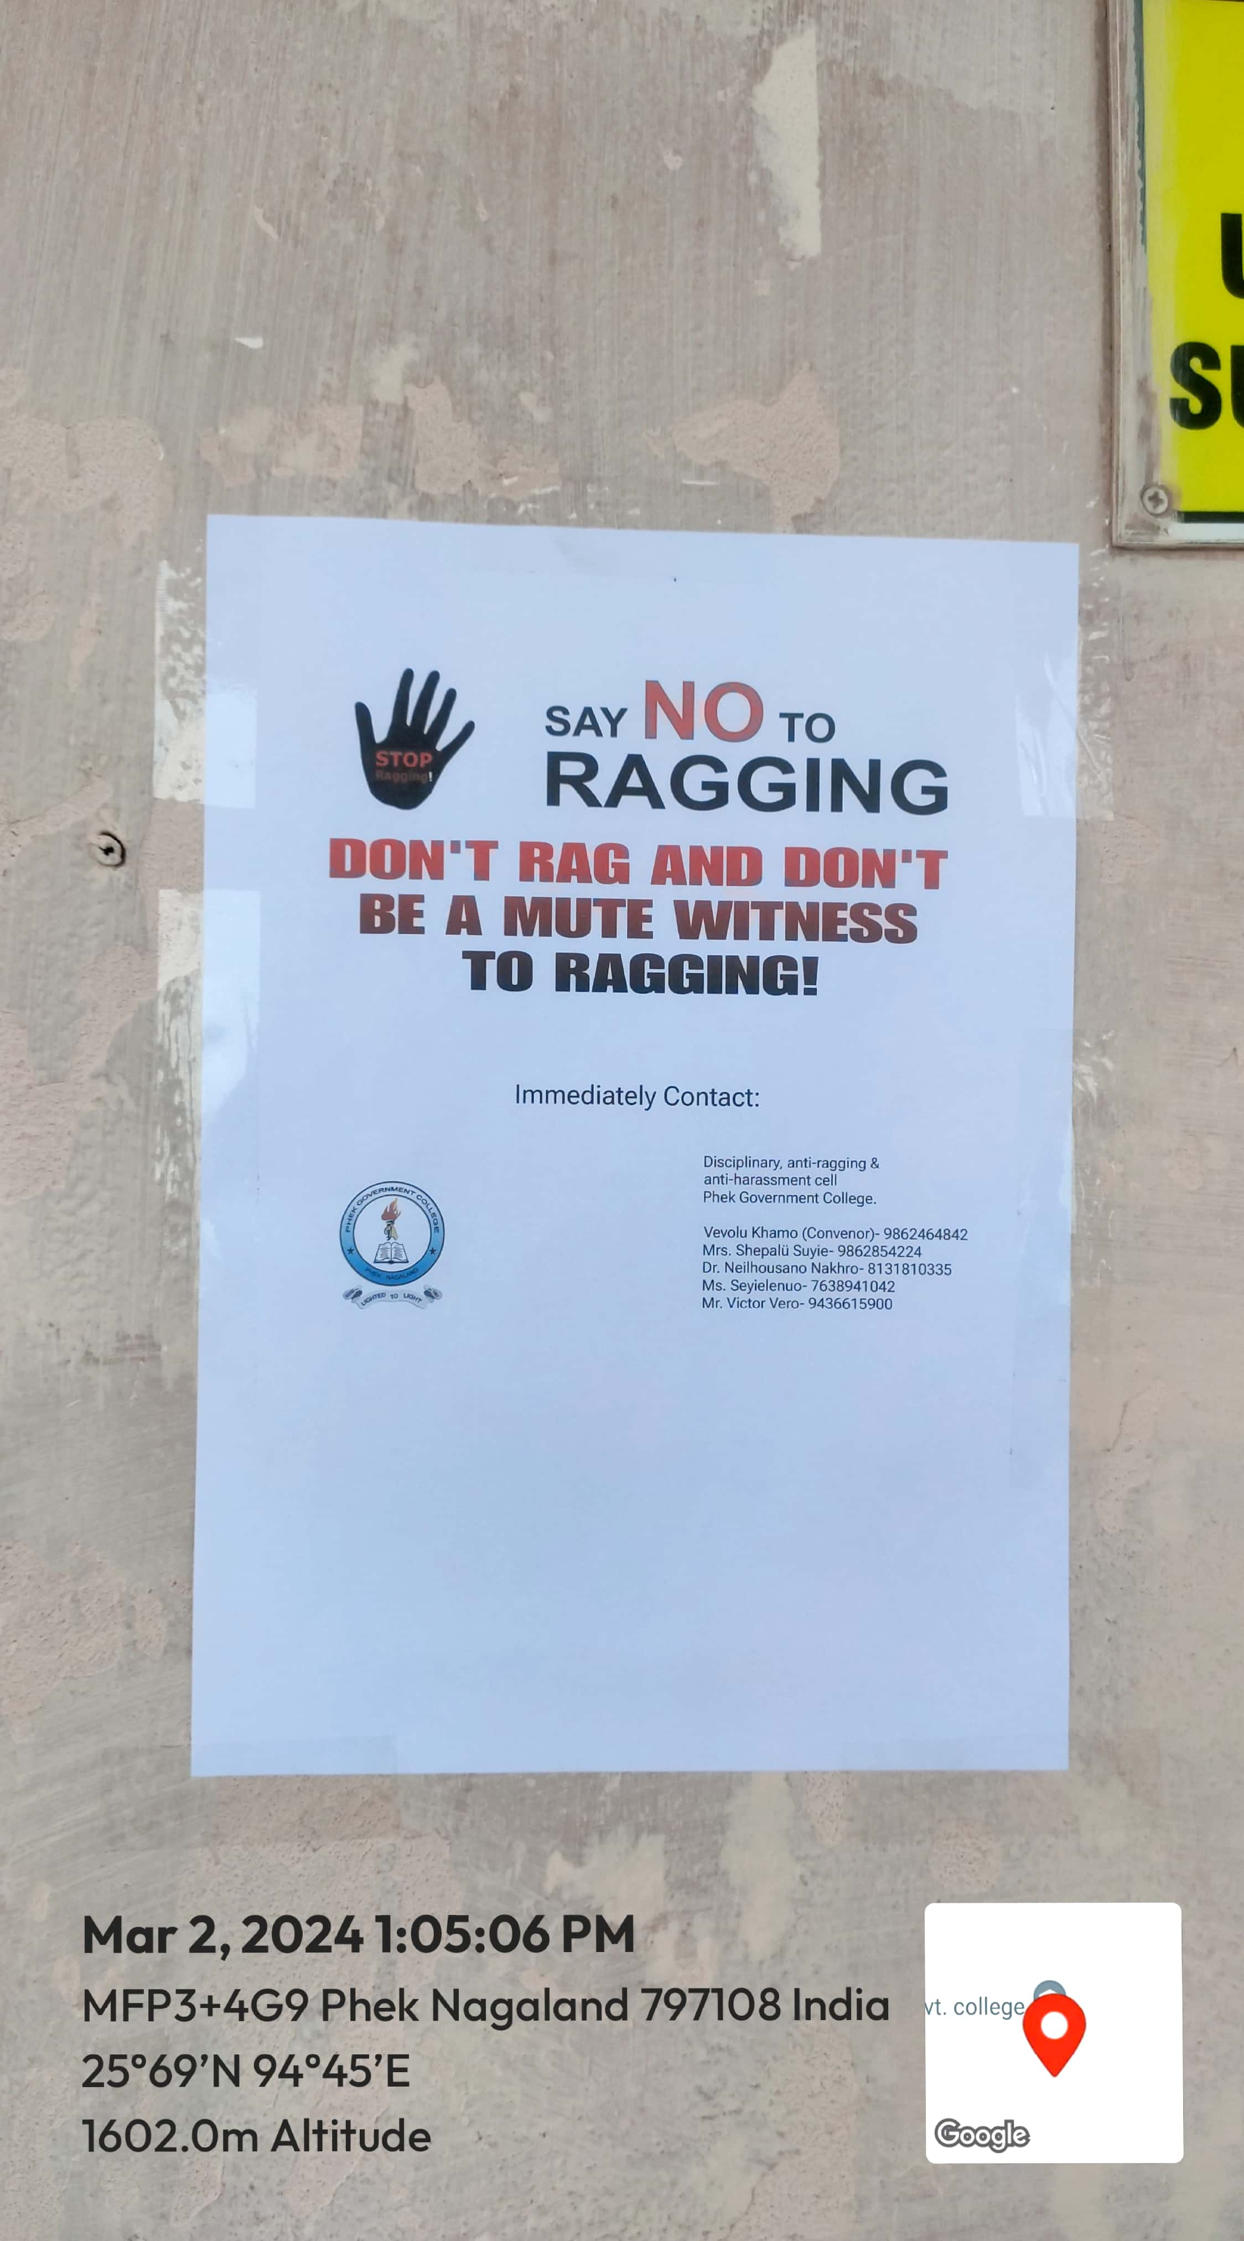

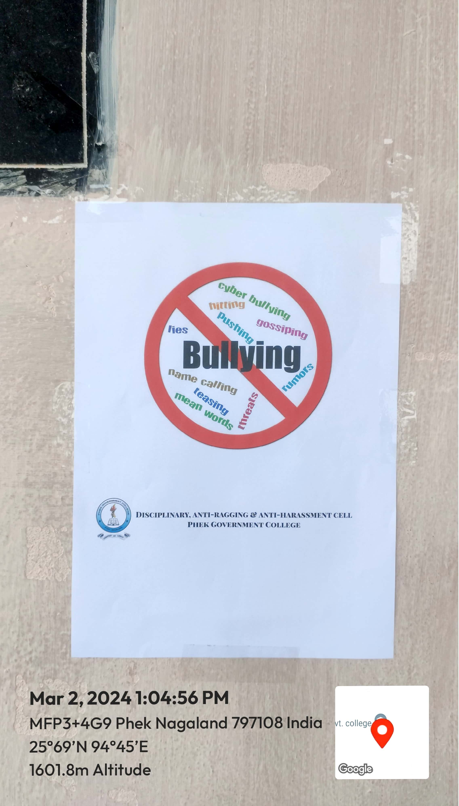

Notice Board with Contact Details of Members of the Disciplinary, anti-ragging and anti- harassment Cell

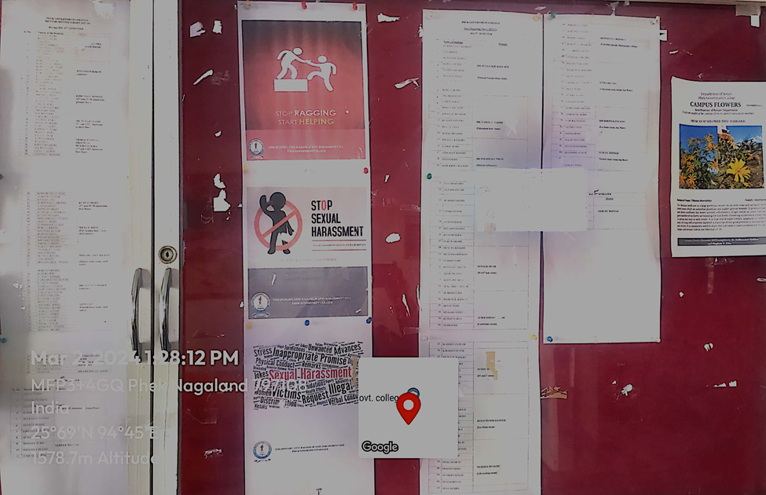

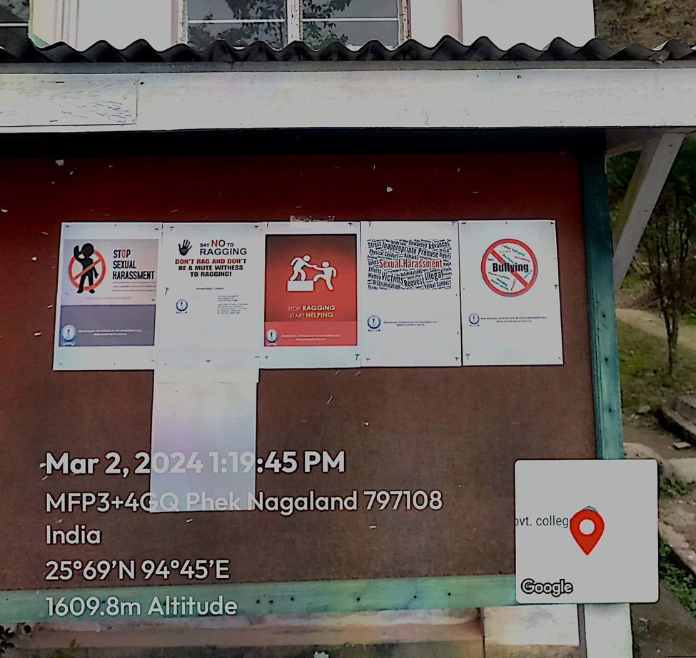

Mechanisms for submission of online/offline students’ grievances
The Disciplinary, anti-ragging and anti- harassment Cell also functions as the body that looks into the grievances of the students, along with matters of harassment.
At present, the mechanism for submission of grievances for the students is carried out through a ‘Grievance Box’. A Grievance Form is to be filled up by the complainant and then dropped into the said box. The concerned Cell is to check the box for any grievances every Friday, and further take the necessary action.

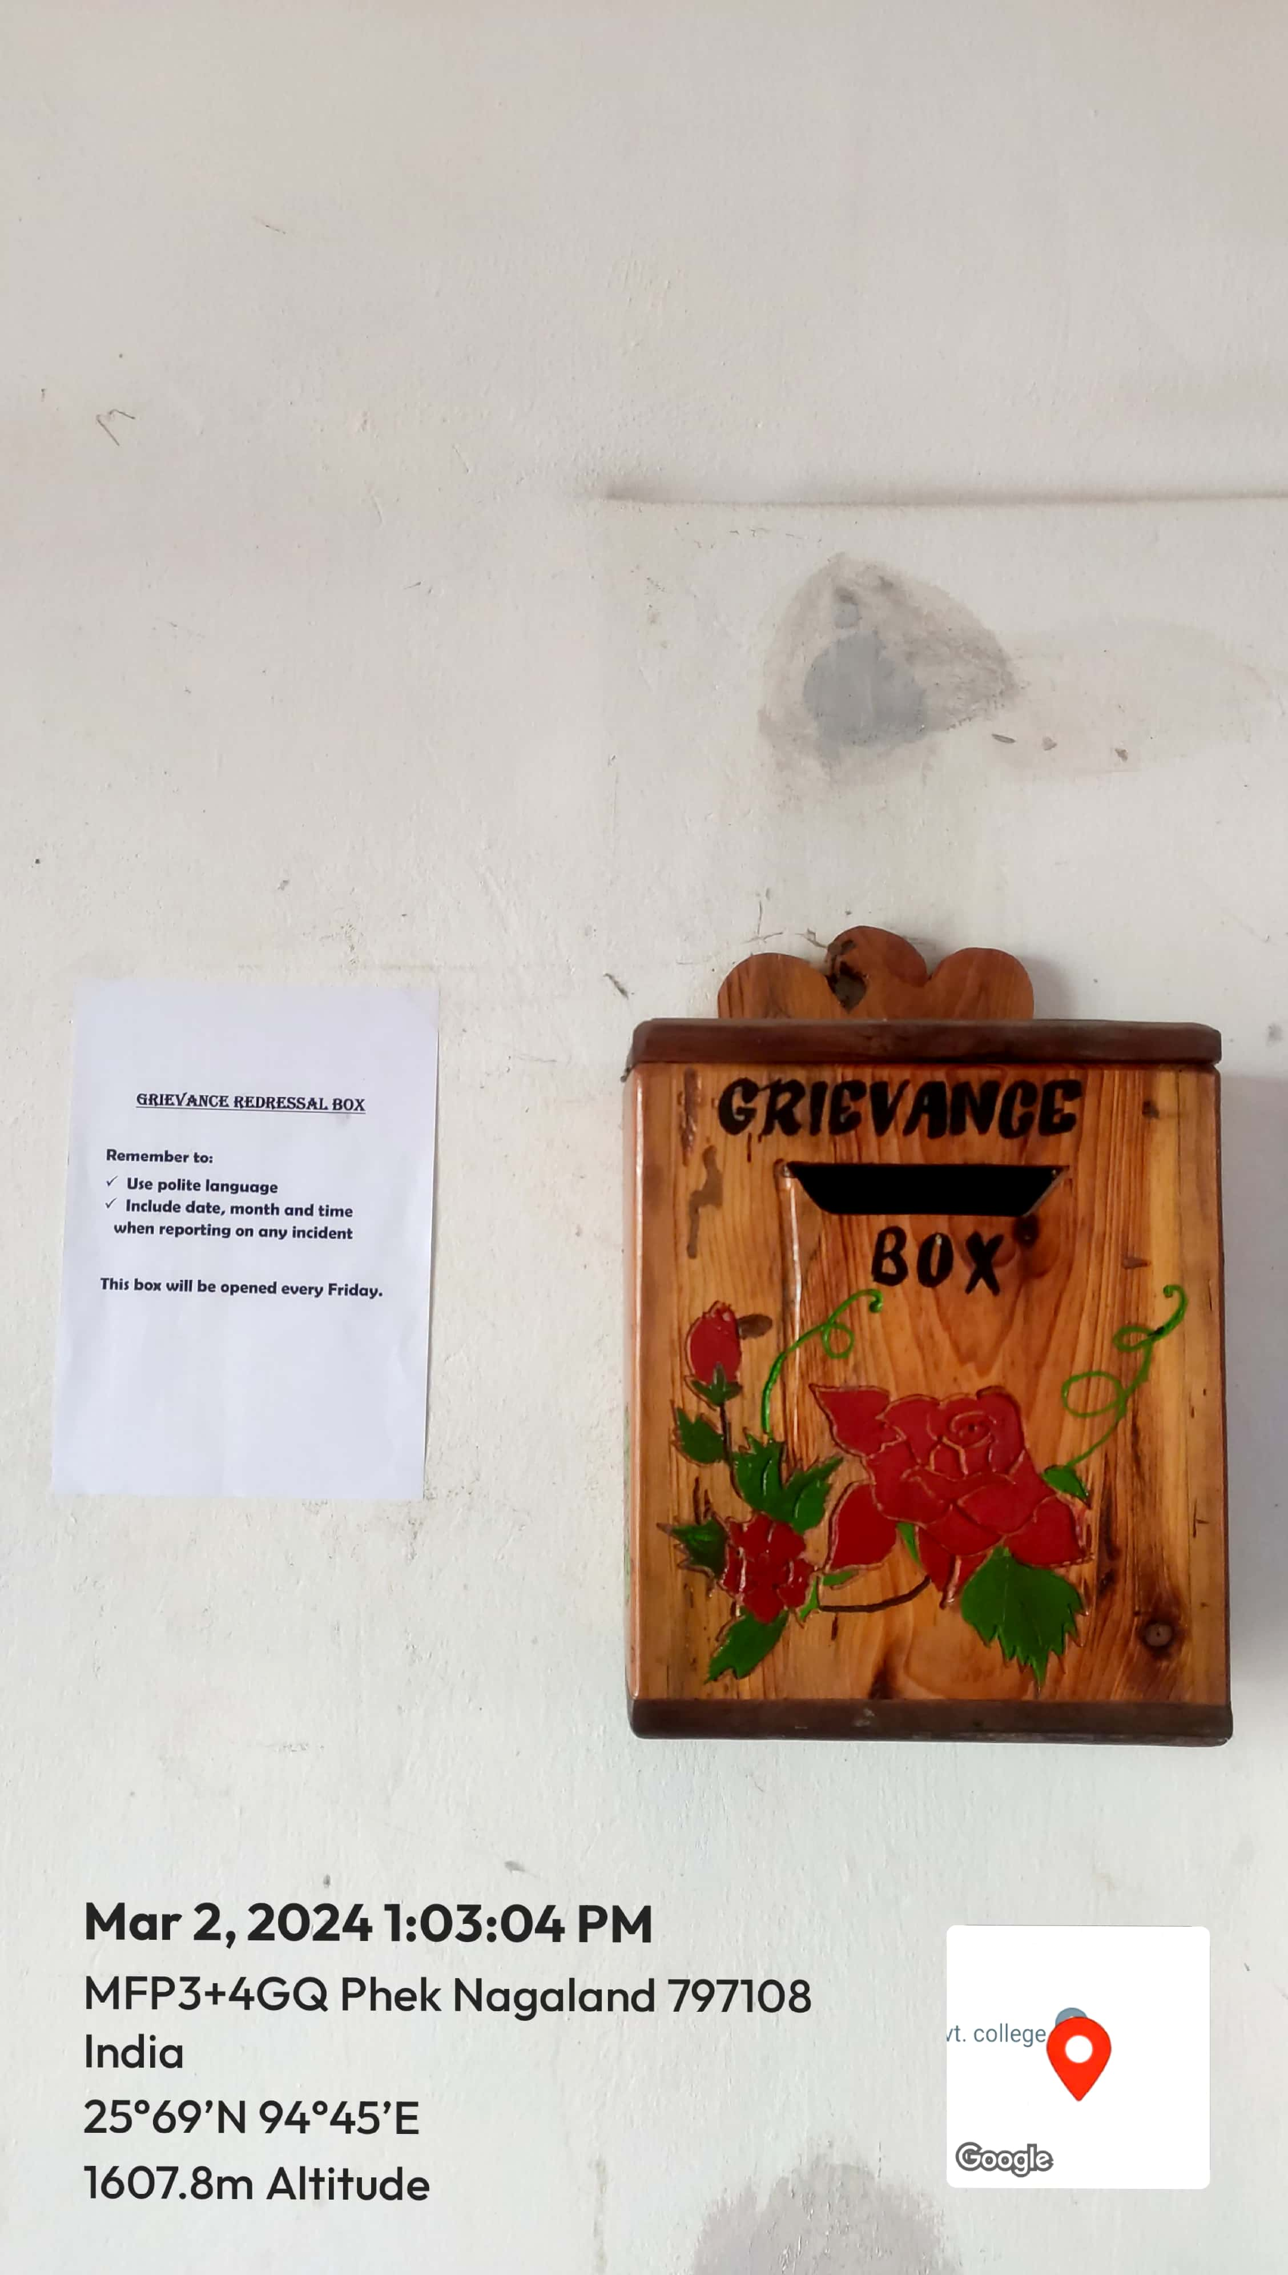
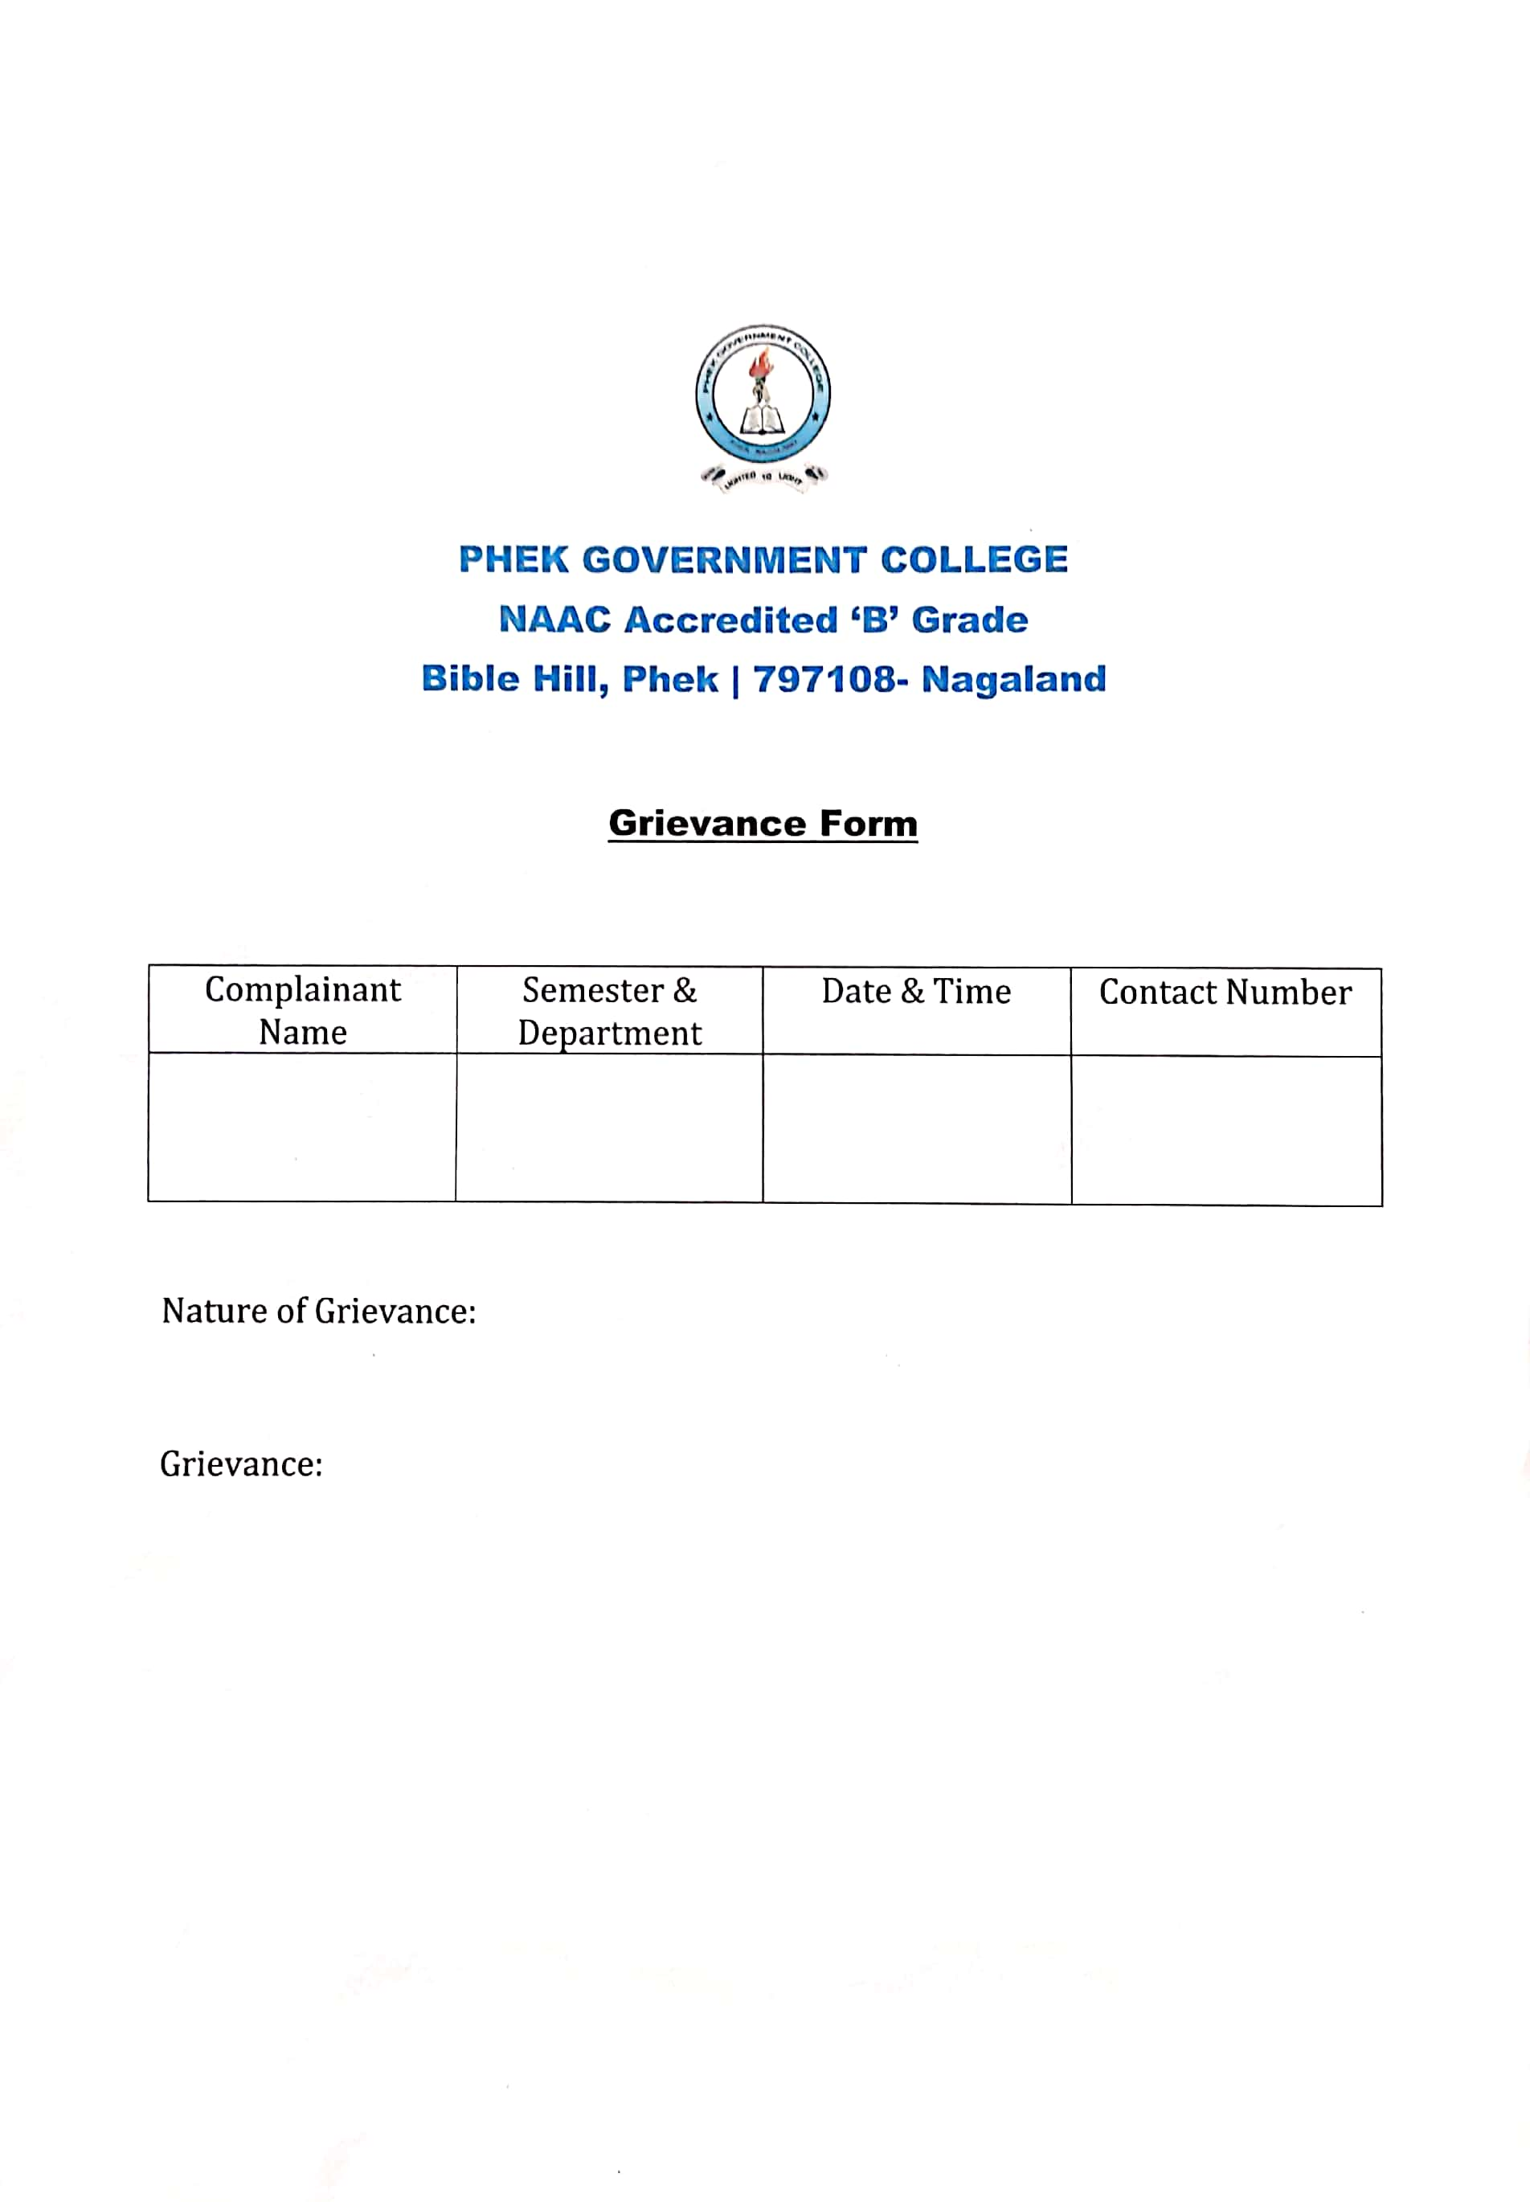

Implementation of guidelines of statutory/ regulatory bodies

The college constituted the Disciplinary, anti-ragging and anti- harassment Cell in the year 2015.
For the redressal of any type of grievances of students, faculty and staffs, the Cell works in consultation with the Principal, IQAC and Students’ Advisory Committee. It is also vested with the authority to take the necessary disciplinary action against any kind of misbehavior.
Periodic meetings of the members are held.

Details of statutory/regulatory Committees

The Present members of the Disciplinary, anti-ragging and anti- harassment Cell were constituted in November, 2023.

Mrs. Vevolu Khamo (Convenor)
Mrs. Shepalü Suyie (Vice Principal)
Dr. Neilhousano Nakhro
Ms. Seyielenuo
Mr. Victor Vero

(Cell and Committees list)

