BOTANY DEPARTMENT AQAR 2023
- FIELDWORK UNDERTAKEN IN 2023 BY BOTANY DEPARTMENT, PGC:
Date | Programme Name | Programme Code | Place | Name of Students | Remarks
1 April 2023 | B. Sc. 4th & 6th sem | BOT 404 & BOT 603(e) | Mount Zanibu, Phek via Pholami village | - Shelu Vero  - Vekhruto Nienu  - Kewerate-u L. Mero  - Kotezo Lasuh | Field trip conducted for botany honours paper
14 October 2023 | B. Sc. 3rd & 5th sem | BGE 03 & BOT 503 | A private Solar Dryer & Botanical Garden at Porba | - Shurhoveku Lohe  - Ukolu Hoshi  - Velotselu S. Venuh  - Shelu Vero  - Vekhruto Nienu | Field trip conducted by Science Club, PGC.

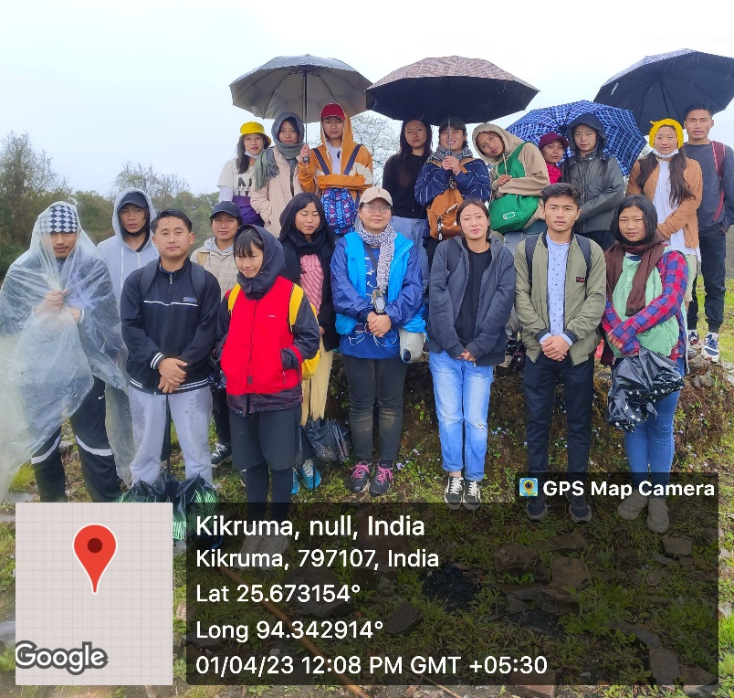
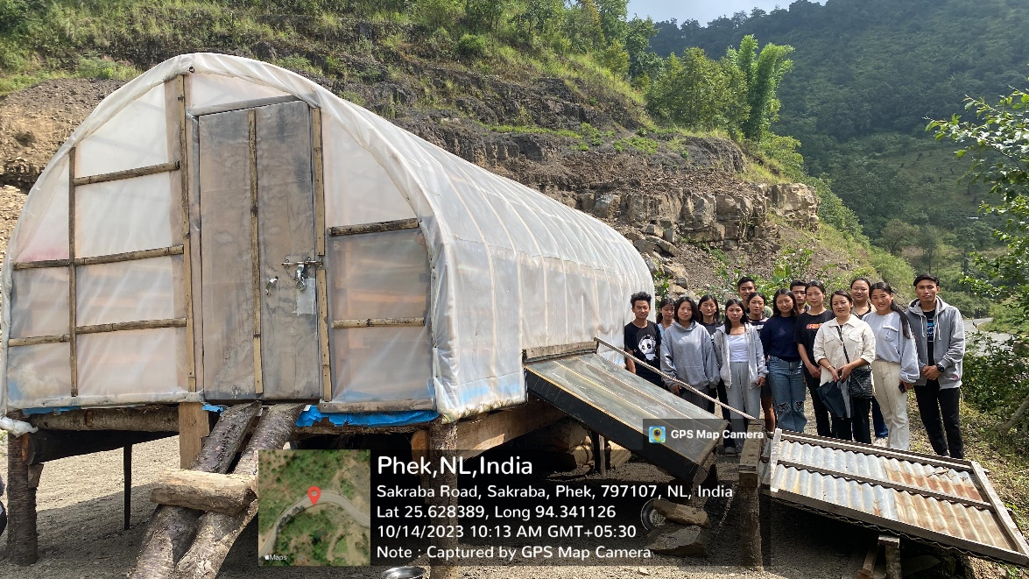
- CLASS PROJECTS UNDERTAKEN IN 2023:
Paper Code | Program Name | No of students | Names of Students | Remarks
BOT-604 | B.Sc. 6th sem (Hon) | 2 | - Kewerate-u L. Mero  - Kotezo Lasuh
 | TOTAL | 2
COMPLETION CERTIFICATE: attached
- MUSHROOM CULTIVATION COURSE:
Course Name | Course Duration | Total No of Students | Names of the Students
CBCS-Mushroom Cultivation in lieu of EVS II for BA 6th semester | January to May 2023 | 21 | - NUCHIKHO VENUH  - THEJASETO POHENA  - ZUVELU RHAKHO  - NUNOLU TETSEO  - HUPA PURO  - ROSEMARY KHUVUNG  - KUTE-U L MERO  - RAVELU KHESOH  - TSHENEIVE-U NUH  - VELUVOLU TETSE-O  - KHRUZOLU NAKRO  - KUNUNULU HOSHI  - KUNUSALU CHIZO  - ZHOPHIVE RHAKHO  - NCHUMBENI EZUNG  - HUZOTO CHIZO  - KUVENOLU VERO  - MHASIVINO MERO  - MULEHU RHAKHO  - SHEZOVOLU THULUO  - VESULU VESWU

- STUDENTS’ PROGRESSION:
YEAR OF PASSING | TOTAL NO OF BOTANY HONOURS STUDENTS PASSED | PASS PERCENTAGE | STUDENTS’ PROGRESSION
2023 | 2 | 100 % | 1. Kewerate-u L. Mero – pursuing D. El. Ed. From District Institute of Education and Training, Pfutsero.  2. Kotezo Lasuh – pursuing M. Sc. in Environmental Science from Nagaland University

- WORKSHOPS ORGANIZED:
Date | Name of the workshop/training, etc. | Resource Persons | No of participants
Date | Name of the workshop/training, etc. | Resource Persons | Teachers | Students | Total
31 Mar 2023 | Demonstration program on Cultivation of Shiitake Mushroom (Lentinula edodes) using logs | - Dr. Neilhousano Nakhro  - Ms. Shesalu Lohe | 19 | 41 | 60
Report of the Event: 31 MARCH 2023
A Demonstration program on Cultivation of Shiitake Mushroom (Lentinula edodes) using logs was organized by Department of Botany, Phek Government College on the 31st of March 2023 at the Skill Centre of the college.
The trainers of the demonstration program were Dr. Neilhousano Nakhro and Ms. Shesalu Lohe, Assistant Professors, Department of Botany, PGC. Dr. Neilhousano Nakhro gave a talk on the importance of shiitake mushroom, procedures involved in the cultivation, and the steps for its maintenance. The students of B. Sc. 6th semester Botany honours and B.A. 6th semester taking Mushroom cultivation as choice-based credit paper provided the hands-on-demonstration on the cultivation technique. Demonstration on preparation of logs, inoculation of spawn, sealing and stacking methods were carried out by them.
Dr. T. Tiakaba Jamir, Principal, Phek Government College emphasized on the need to organize more programs related to development of skill during the interactive session. He also added that with the implementation of National Education Policy 2020 such programs will become more significant.

Picture of the Event: (Geotagged pictures) 31 MARCH 2023
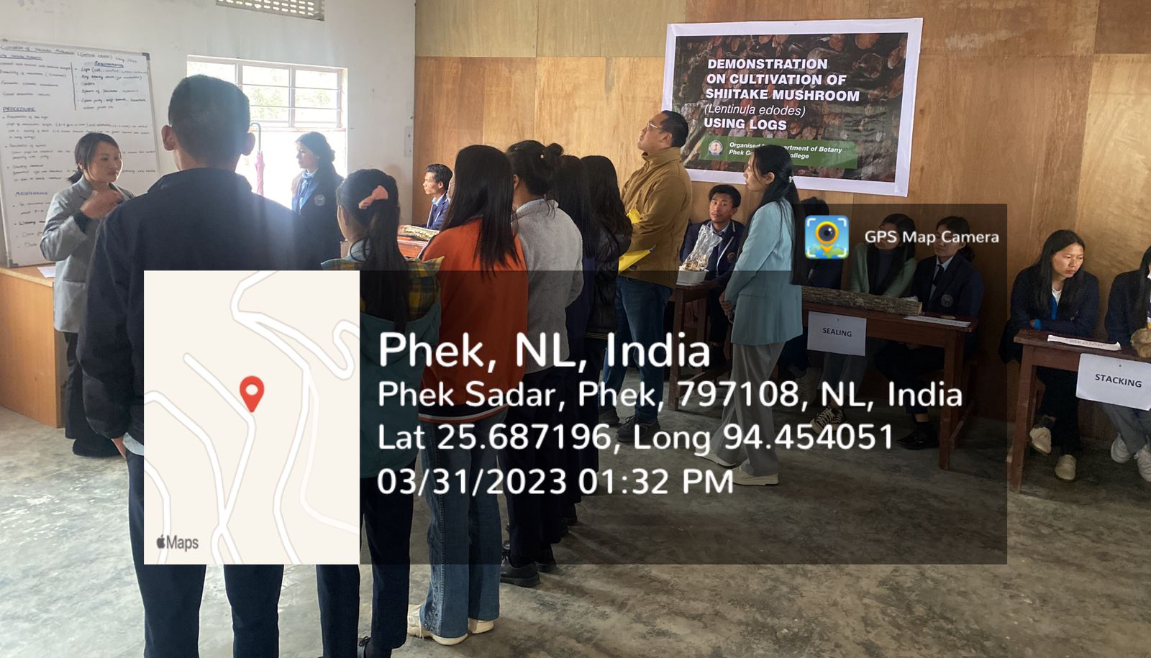
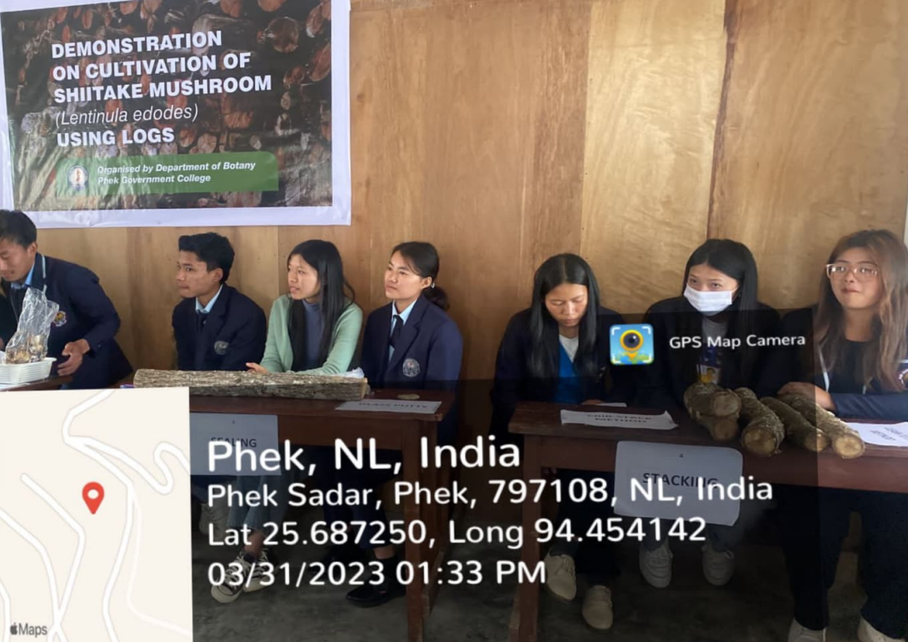

Attendance Proof

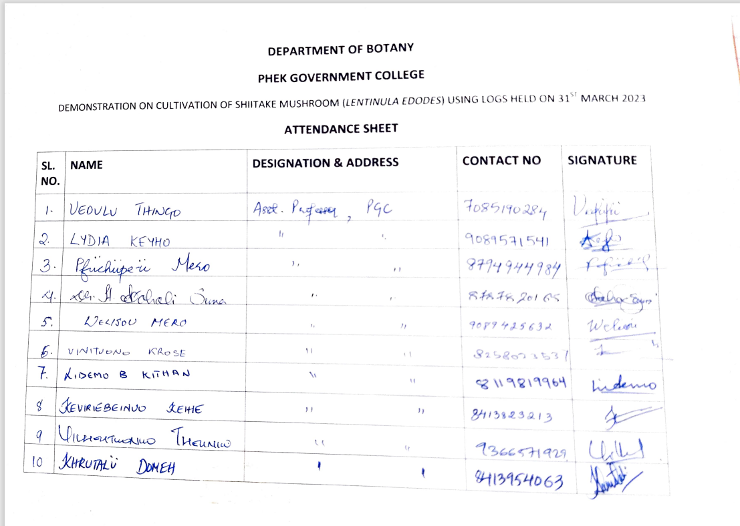
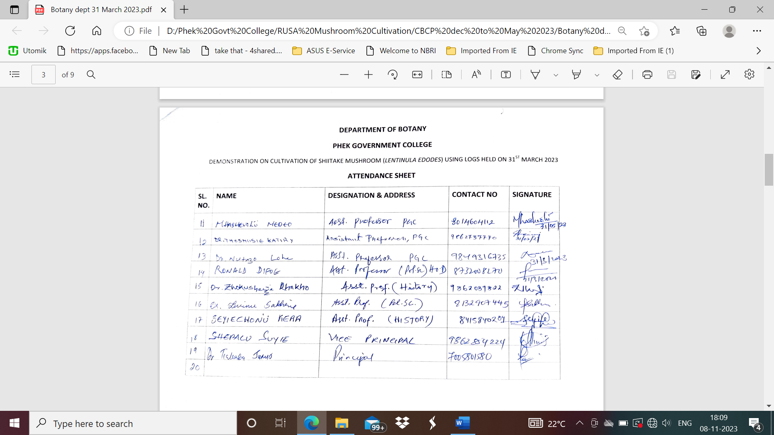
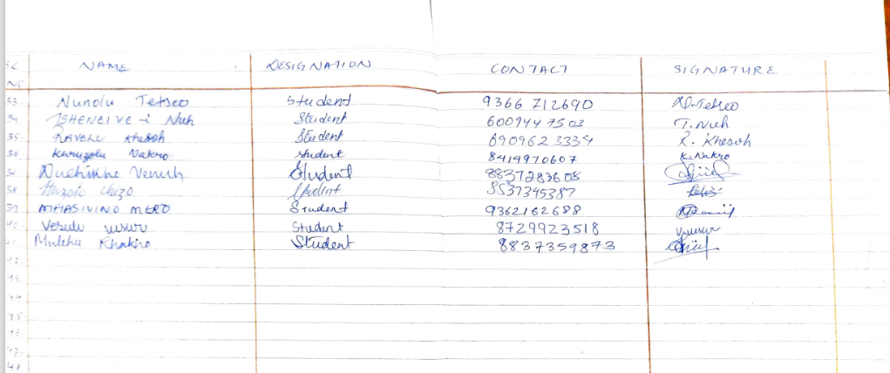

- AWARDS RECEIVED BY STUDENTS:
Date | Name of program | Student’s name | Category/position
23 Aug 2023 | District level literary competition on the theme ‘Improving millets production through science’ | Vekhruto Nienu | 2nd Position
23 Aug 2023 | District level literary competition on the theme ‘Improving millets production through science’ | Ukolu Hoshi and Velotselu S. Venuh | 3rd position
1 Sep 2023 | State level literary competition on the theme ‘Improving millets production through science’ | Vekhruto Nienu | Consolation winner
12 Aug 2023 | District level Youth Fest Marathon race ‘Youth for HIV/AIDS’ | Vekhruto Nienu | 1st position
