BOTANY DEPARTMENT AQAR 2024
- FIELDWORK UNDERTAKEN IN 2023 BY BOTANY DEPARTMENT, PGC:
Date | Programme Name | Programme Code | Place | Name of Students | Remarks
10 February 2024 | B. Sc. 6th sem | BOT 604 | Shiitake mushroom cultivation site at Khomi Village, Phek | - Shelu Vero  - Vekhruto Nienu  - Munulu Vese | Field trip conducted for botany honours project paper
25 to 27 March 2024 | B. Sc. 2nd, 4th & 6th sem |  | Zoological Park Rangapahar, Green Park & Science centre, Dimapur | Dzuveta Khesoh  Veba Venuh  Shurhoveku Lohe  Ukolu Hoshi  Chandan Sha  Rakho Puro  Rulevelu Venuh  Mululu Hoshi  Kulutho Vero  Sheralu Puro  Hunulu Hoshi  Shelu Vero  Kimdiana Haolai  Zomunulu Vese  Vekhruto Nienu  Munulu Vese | Educational trip/ Mr. Mughato K. Kiba (Teacher in charge)
15 and 16 October 2024 | B. Sc. 1st, 3rd & 5th |  | Zoological Park Rangapahar, Nagaland Mini Tools & Training Centre, Aboriginals energy & Nagaland Pollution Control Board, Dimapur | Dzuveta Khesoh  Veba Venuh  Shurhoveku Lohe  Dzuponu Venuh  Tsunelu Vero  Huduyi Venuh | Educational trip/ Dr. Neilhousano Nakhro and Mr. Mughato K. Kiba (Teacher in charges)

FIELD TRIP: 10 FEBRUARY 2024
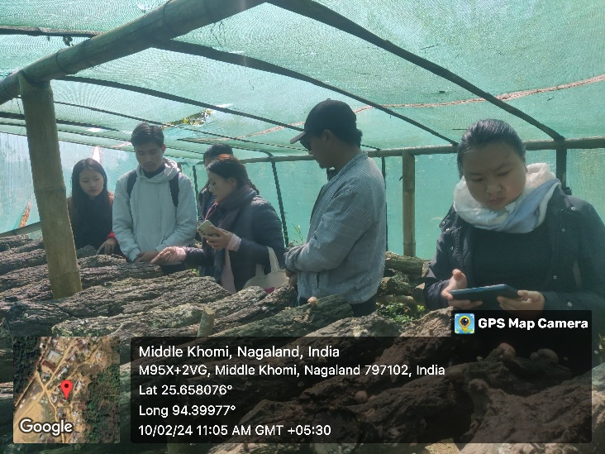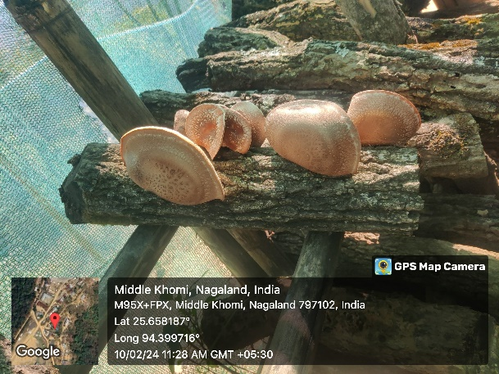
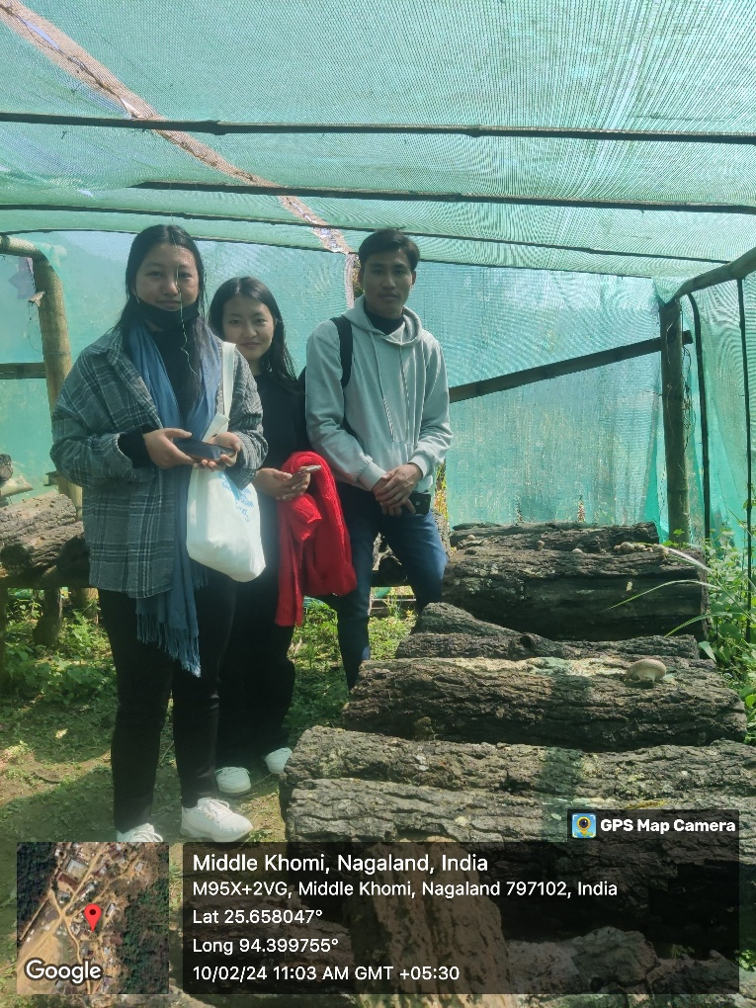
EDUCATIONAL TRIP: 25 TO 27 MARCH 2024
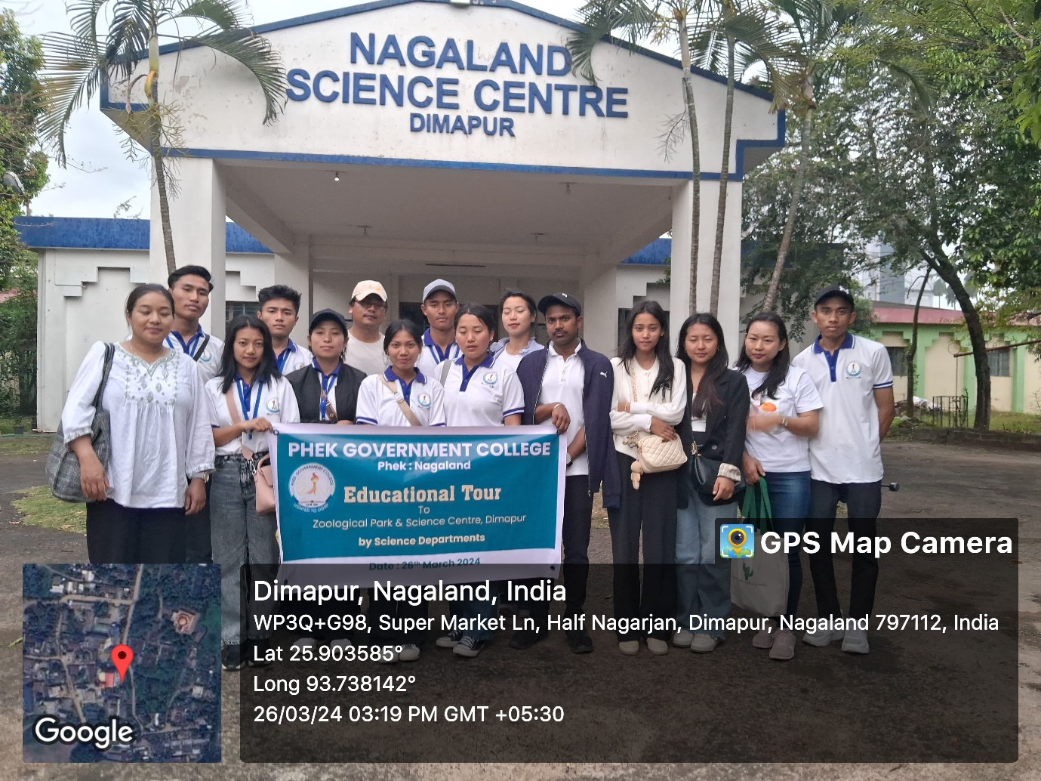
EDUCATIONAL TRIP: 15 and 16 October 2024

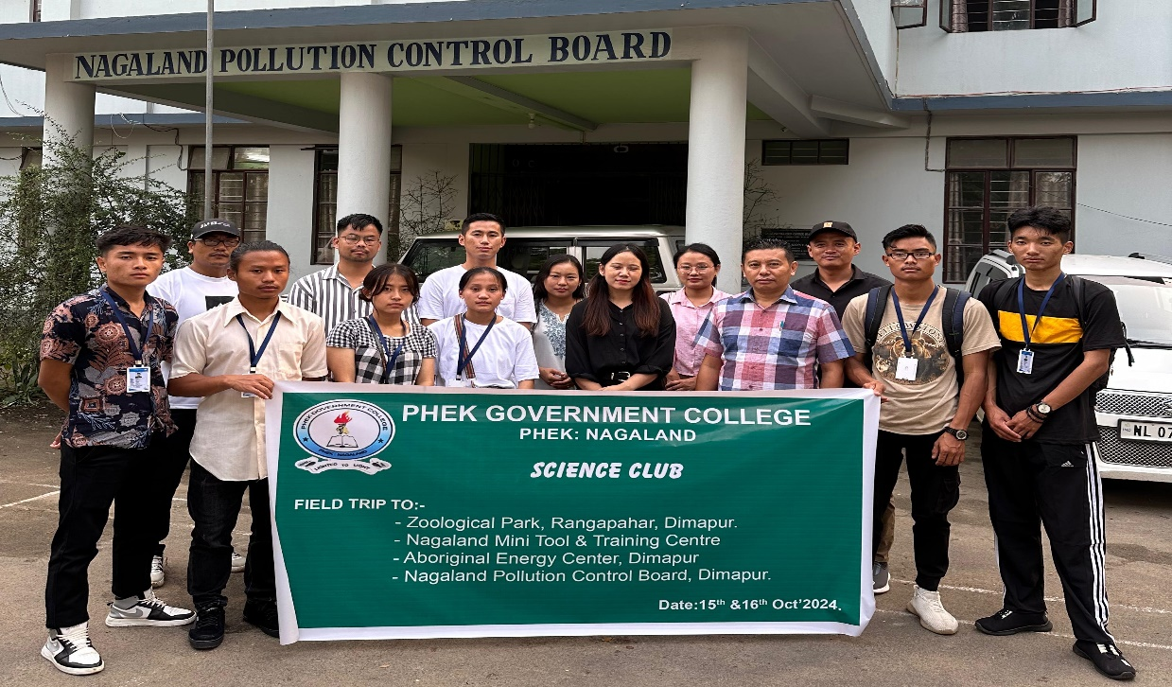
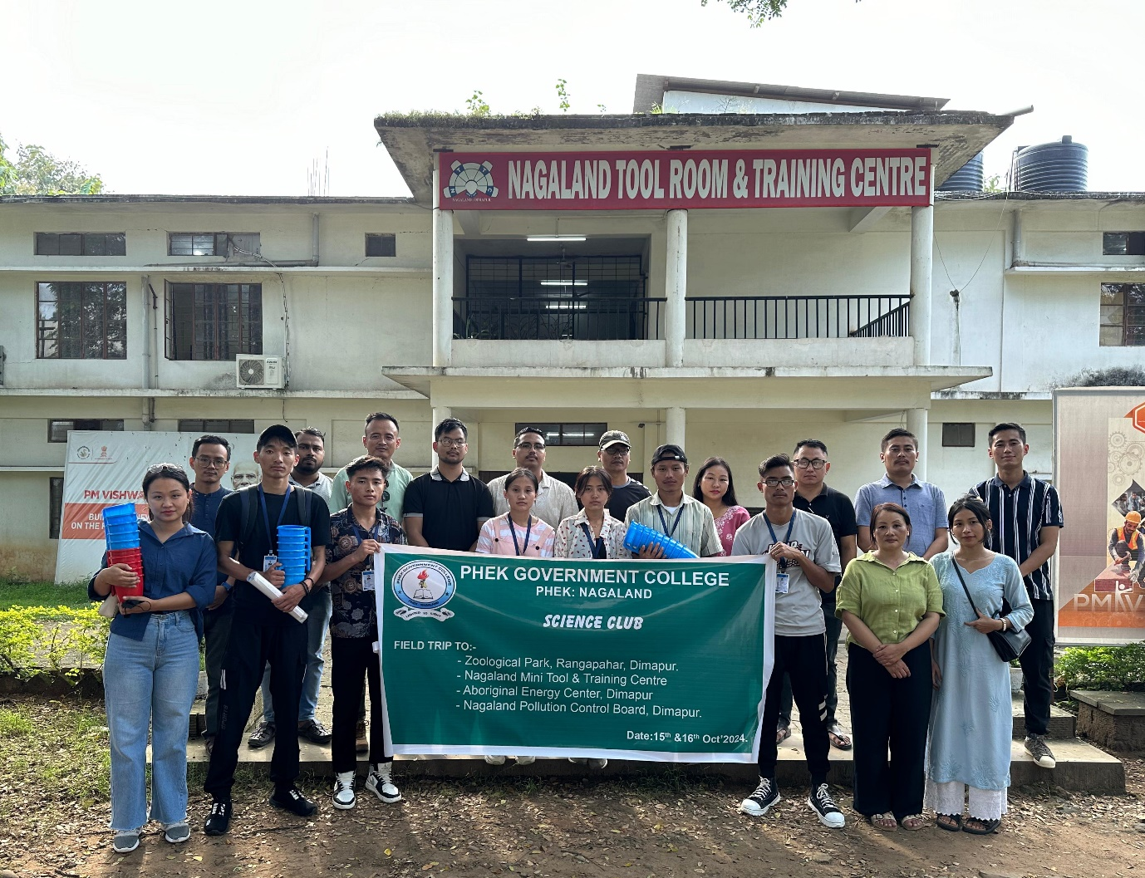
- CLASS PROJECTS UNDERTAKEN IN 2024:
Paper Code | Program Name | No of students | Names of Students | Remarks
EVS- 601 | B.Sc. 6th sem | 3 | - Shelu Vero  - Kulutho Vero  - Vekhruto Nienu
BOT-604 | B.Sc. 6th sem (Hon) | 3 | - Shelu Vero  - Vekhruto Nienu  - Munulu Vese
 | TOTAL | 6
COMPLETION CERTIFICATE (attached)

DEPARTMENT OF BOTANY
PHEK GOVERNMENT COLLEGE
PHEK, NAGALAND-797108

CLASS PROJECT DETAILS ON ENVIRONMENTAL STUDIES 2024

SL. NO. | NAME OF THE STUDENT | TITLE OF THE PROJECT | PLACE OF WORK | DURATION
1 | SHELU VERO | IDENTIFICATION AND DOCUMENTATION OF FIVE PLANT SPECIES FOUND IN THE COLLEGE CAMPUS | PHEK GOVERNMENT COLLEGE, PHEK, NAGALAND | MARCH 2024
2 | VEKHRUTO NIENU | IDENTIFICATION AND DOCUMENTATION OF FIVE PLANT SPECIES FOUND IN THE COLLEGE CAMPUS | PHEK GOVERNMENT COLLEGE, PHEK, NAGALAND | MARCH 2024
3 | KULUTHO VERO | IDENTIFICATION AND DOCUMENTATION OF FIVE PLANT SPECIES FOUND IN THE COLLEGE CAMPUS | PHEK GOVERNMENT COLLEGE, PHEK, NAGALAND | MARCH 2024

- MUSHROOM CULTIVATION COURSE:
Course Name | Course Duration | Total No of Students | Names of the Students
CBCS-Mushroom Cultivation in lieu of EVS II for BA 6th semester | January to May 2024 | 25 | - BAVETO HUIRE  - DZUTHONULU NIENU  - EKOHIWE-U  - KHRULU VENUH  - KHRUVOLU DOZO  - KULUTHI KHAMO  - KULUTSOLU HOSHI  - LICHU-U KEPFO  - NUZOVOLU VASA  - SEKHO VESWU  - SHEHUVO HOSHI  - THUJOVE VERO  - THUNOZULU KEYHO  - VEMUCIE VERO  - WESESO-U  - PEWE-U KRONU  - RHITSHO VENUH  - VEVOZOLU LOHE  - KUZHOKU VERO  - NITATU THURR  - RUVETO HOSHI  - VEMUZHOLU KEYHO  - DOVELU VERO  - MUCHITO VENUH  - YEIVETA RHAKHO

- STUDENTS’ PROGRESSION:

YEAR OF PASSING | TOTAL NO OF BOTANY HONOURS STUDENTS PASSED | PASS PERCENTAGE | STUDENTS’ PROGRESSION
2023 | 2 | 67 | Vekhruto Nienu is pursuing M. Sc. in Botany from Nagaland University  Shelu Vero is pursuing M. Sc. in Environmental Science from Nagaland University

- Seminar/Workshop/Programmes/Events: For the Year 2024
Sl. No | Date | Name of the workshop/training, etc. | Resource Persons | No of participants
 |  |  |  | Teachers | Students | Total
1 | 7 March 2024 | Hands-on Demonstration on Cultivation of oyster mushroom (Pleurotus ostreatus) for B. Sc. 6th Semester students  https://phekgovernmentcollege.com/2024/03/27/hands-on-demonstration-on-cultivation-of-oyster-mushroom-pleurotus-ostreatus-for-b-sc-6-semester-students-conducted-on-7-march-2024-by-department-of-botany-pgc/ | - Dr. Neilhousano Nakhro  - Ms. Shesalu Lohe  - Mr. Mughato K. Kiba | - | 8 | 8
2 | 12 April 2024 | Hands-on Demonstration on Cultivation of oyster mushroom (Pleurotus ostreatus) for BA 6th Semester students | Dr. Neilhousano Nakhro | - | 20 | 20

The following are to be submitted along with the above data:
- Report of the Event: (7 March 2024)
A hands-on demonstration program on Cultivation of oyster mushroom (Pleurotus ostreatus) was organized by Department of Botany, Phek Government College on the 7th March 2024 at the Mushroom Cultivation Unit for the B. Sc. 6th semester students. The trainers of the demonstration program were Dr. Neilhousano Nakhro, Ms. Shesalu Lohe and Mr. Mughato K. Kiba, Assistant Professors, Department of Botany, PGC. The requirements, procedures involved in the cultivation, and the steps for its maintenance were highlighted which was followed by the hands-on demonstration.

- Picture of the Event: (Geotagged pictures) 7 March 2024
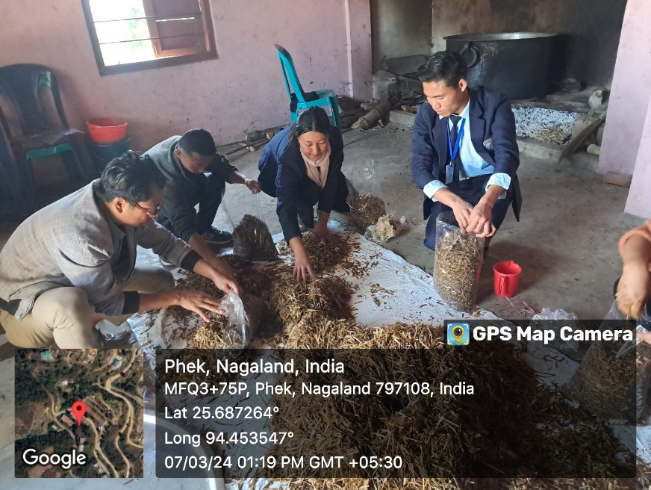
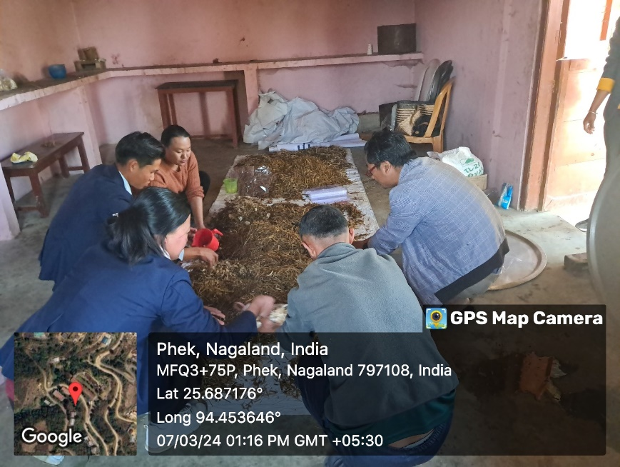

- Attendance proof: 7 March 2024
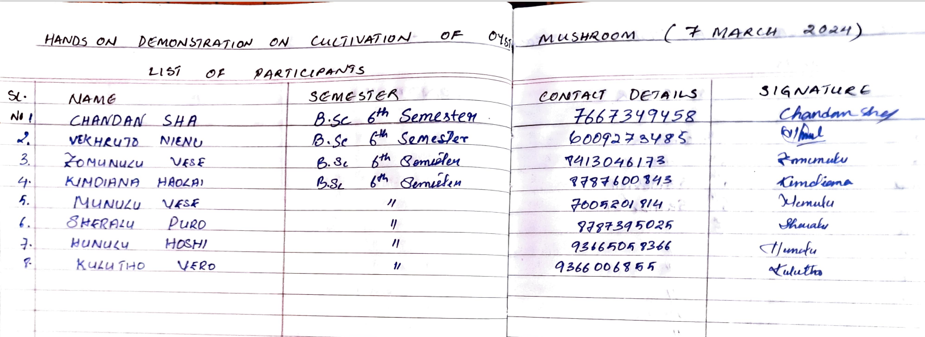
The following are to be submitted along with the above data:
- Report of the Event: (12 April 2024)
A hands-on demonstration program on Cultivation of oyster mushroom (Pleurotus ostreatus) was organized by Department of Botany, Phek Government College on the 12 April 2024 at the Mushroom Cultivation Unit for the BA 6th semester students. Dr. Neilhousano Nakhro, Assistant Professors, Department of Botany, PGC highlighted the requirements, procedures involved in the cultivation of oyster mushroom, and the steps for its maintenance. The substrate used was saw dust instead of paddy straw and for which it was collected by the students from the saw mills located at Phek town and Phek village prior to the demonstration day. The use of saw dust as substrate was to exemplify the theorical approach that any agricultural or organic wastes can be used for the cultivation of oyster mushroom.
- Picture of the Event: (Geotagged pictures) 12 April 2024
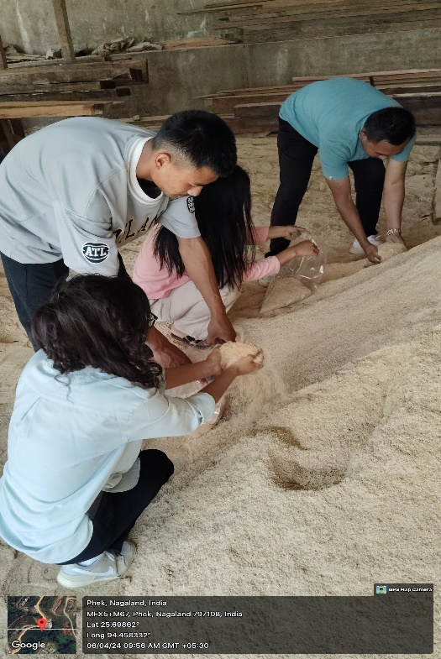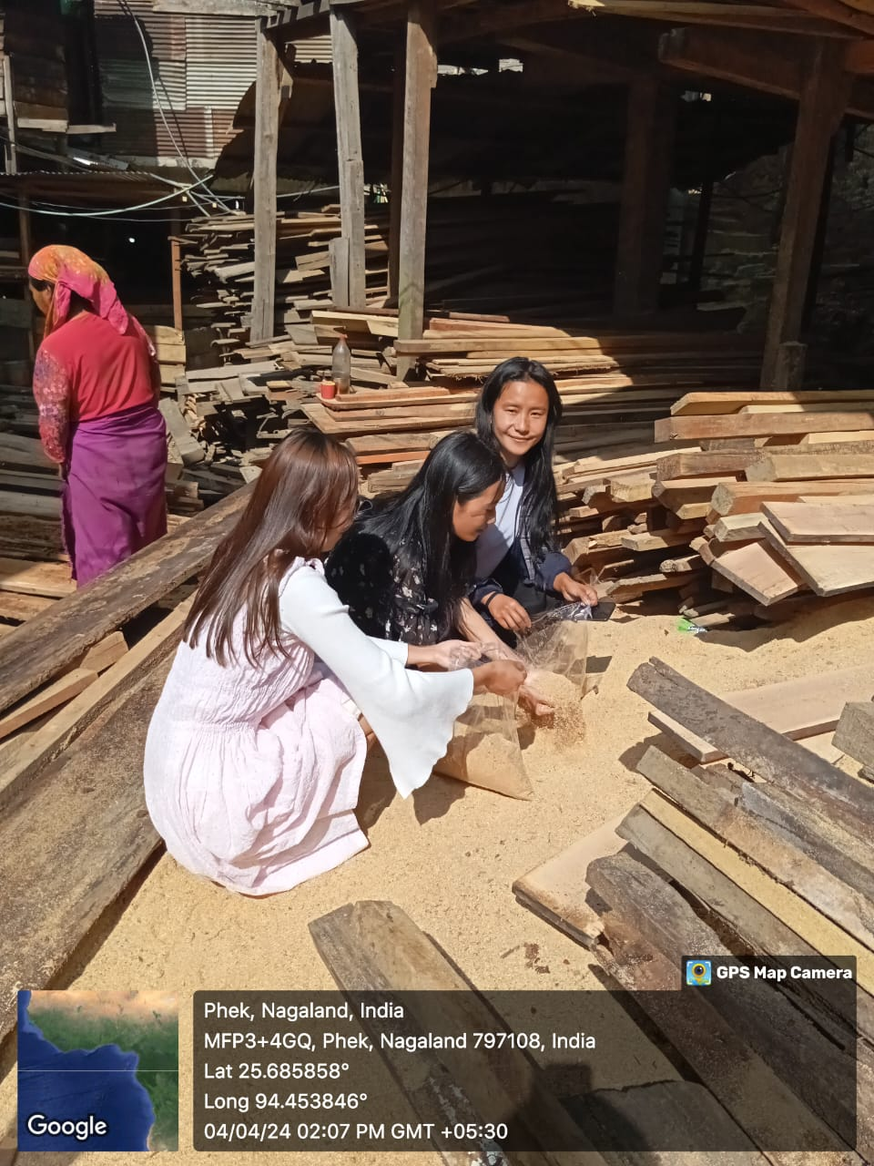
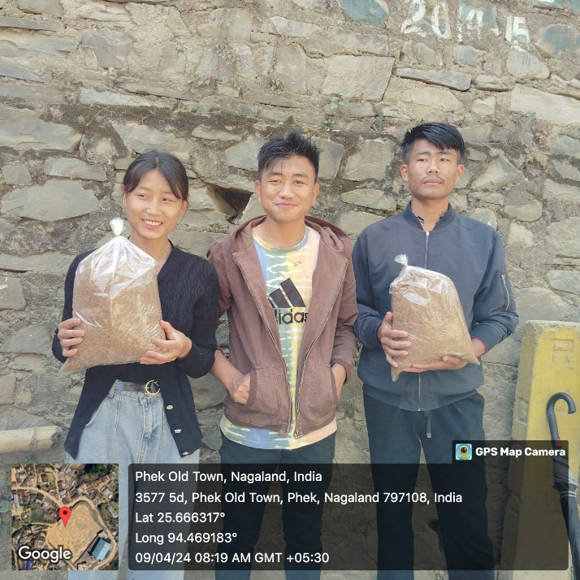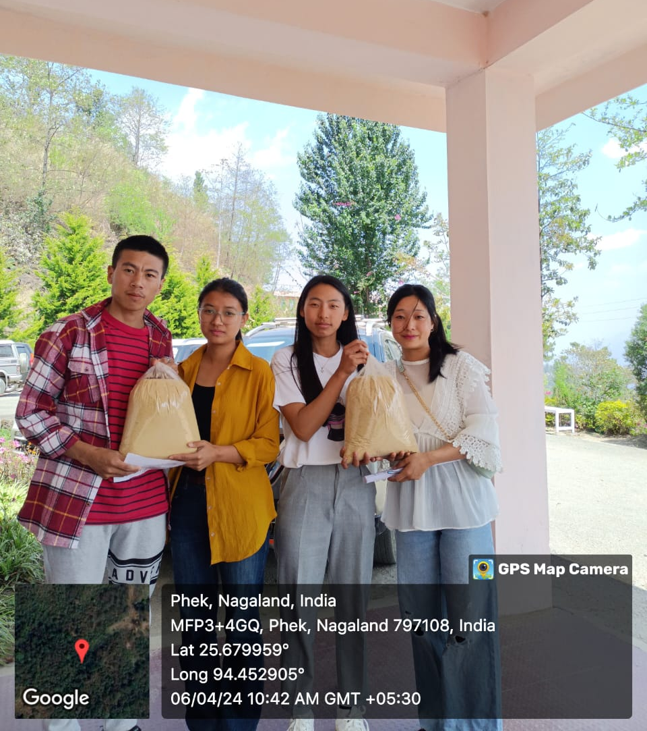
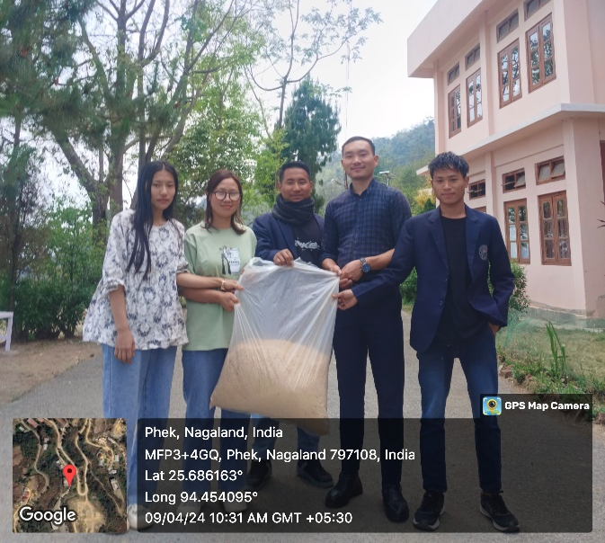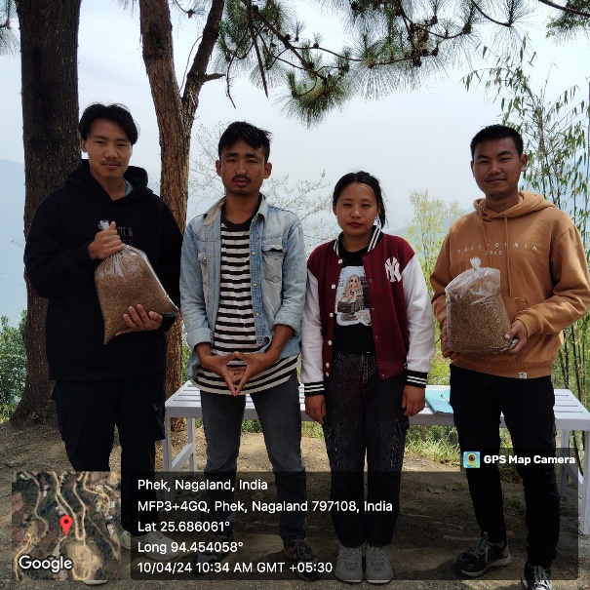
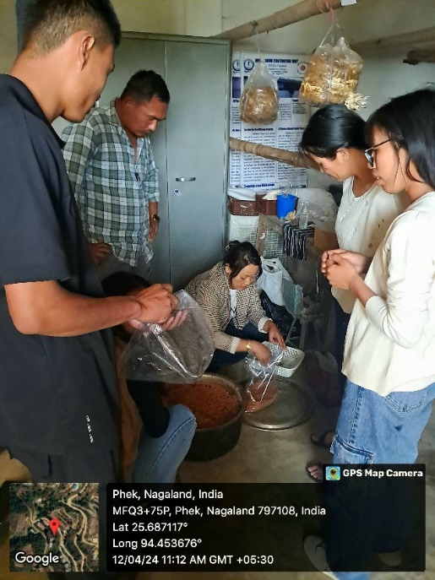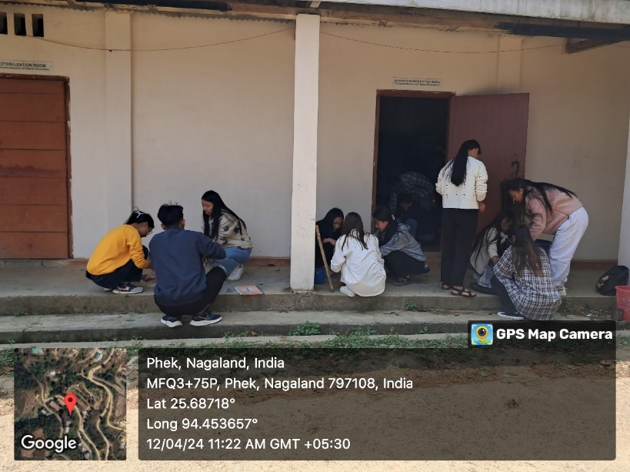
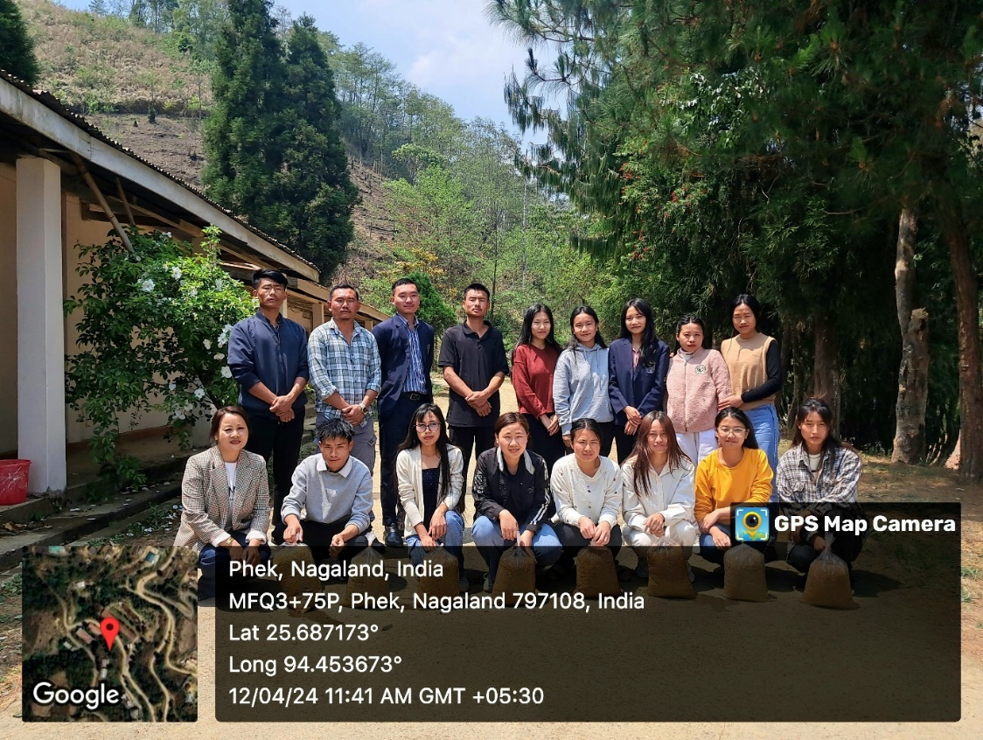
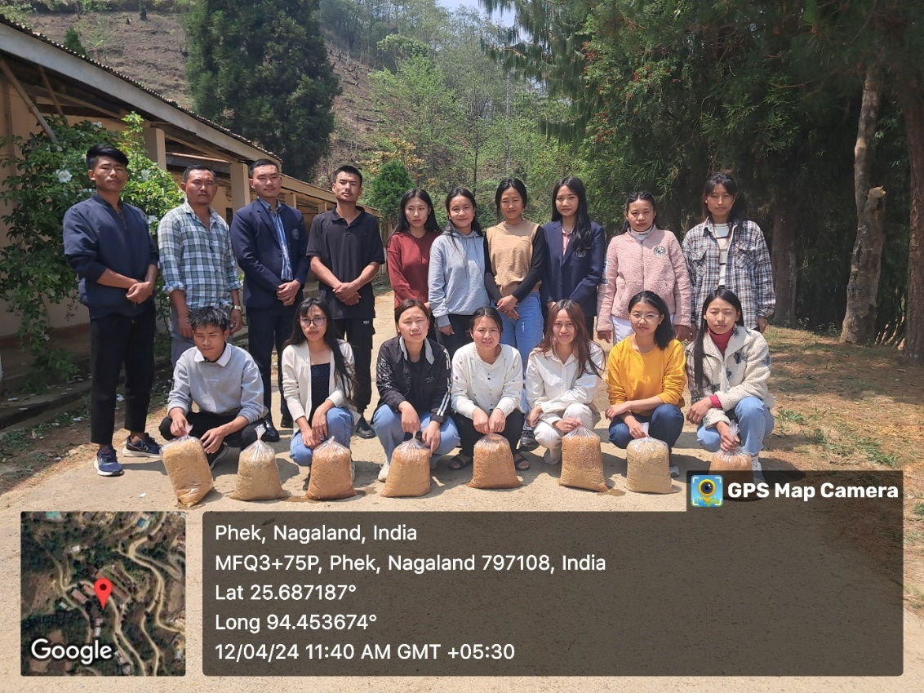

ATTENDANCE PROOF: 12 April 2024
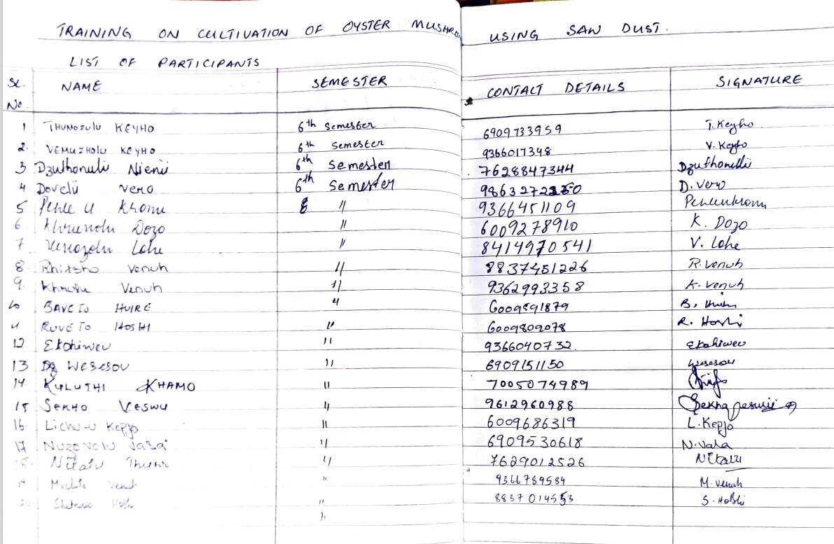
The following are to be submitted along with the above data:

- AWARDS RECEIVED BY STUDENTS:
Date | Name of program | Student’s name | Category/position
- PARTICIPATION BY STUDENTS:
Date | Name of program | Student’s name | Category/position | Title of work carried out
28 FEBRUARY 2024 | NATIONAL SCIENCE DAY CELEBRATION 2024 organized by Science Club, PGC | VEKHRUTO NIENU & DZUVETA KHESOH | PARTICIPANT OF POSTER PRESENTATION | Indigenous cultivation method of foxtail millet (Setaria italica) and its production level at Mutsale Village under Phek District, Nagaland
28 FEBRUARY 2024 | NATIONAL SCIENCE DAY CELEBRATION 2024 organized by Science Club, PGC | SHELU VERO & MUNULU VESE | PARTICIPANT OF POSTER PRESENTATION | Sustainable approach for cultivation of Shiitake mushroom (Lentinula edodes)
