PHEK GOVERNMENT COLLEGE
Department of Physics
Report
A one-day field trip was organized by the Science Club of Phek Government College to Porba under Sakraba range on the 14th of October 2023. Science Club with its mission to learn more science by involving in extra co-curricular activities has all science faculty and students of PGC as its members. The sites visited were a Solar Dryer attached to a private botanical garden owned by an alumnus of PGC, Swuyievezo Dzudou and National Research Centre on Mithun – ICAR, Porba campus.
The B.Sc. 2nd Semester Students taking ‘Renewable energy and energy harvesting’ as skill enhancement course as per CBCS and FYUGP curriculum offered by Physics department got to witness and learn how solar energy is harnessed for drying various products through a solar dryer. The students taking physics paper also acquired first-hand information about the design, construction and performance of a solar dryer.

Submitted by:

(LIDEMO B KITHAN)
Assistant Professor
Department of Physics

Picture of the Event:
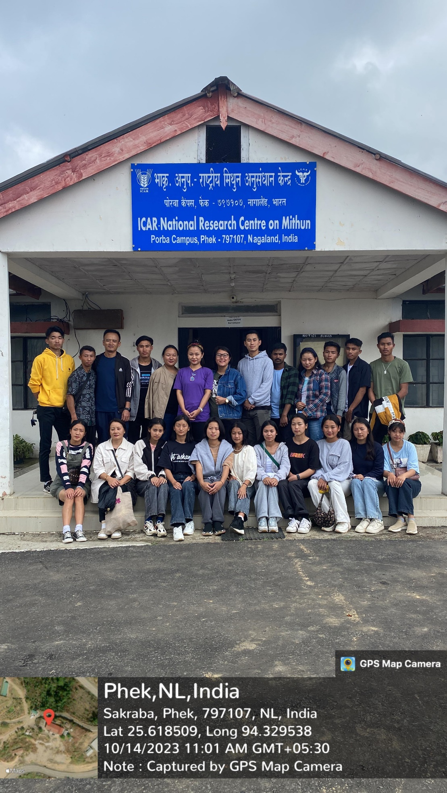

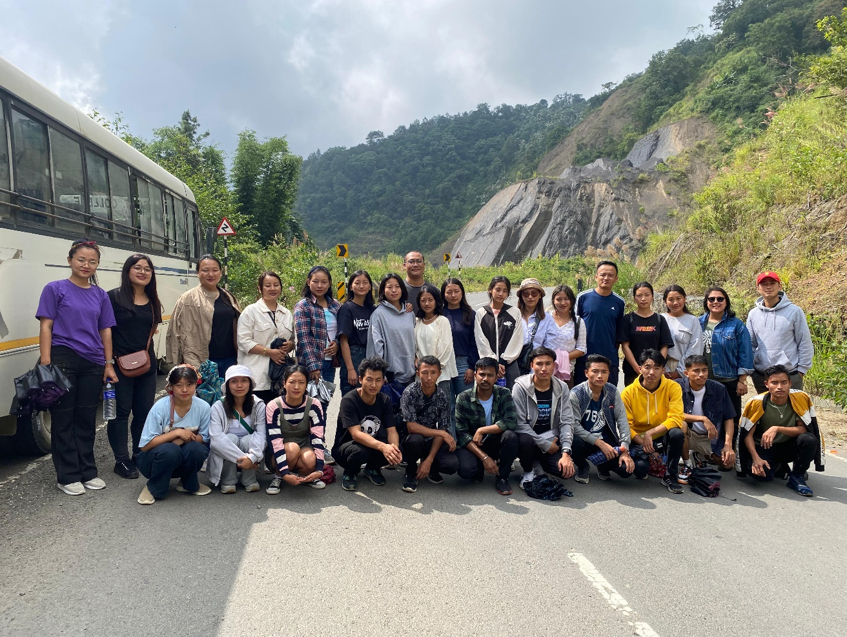
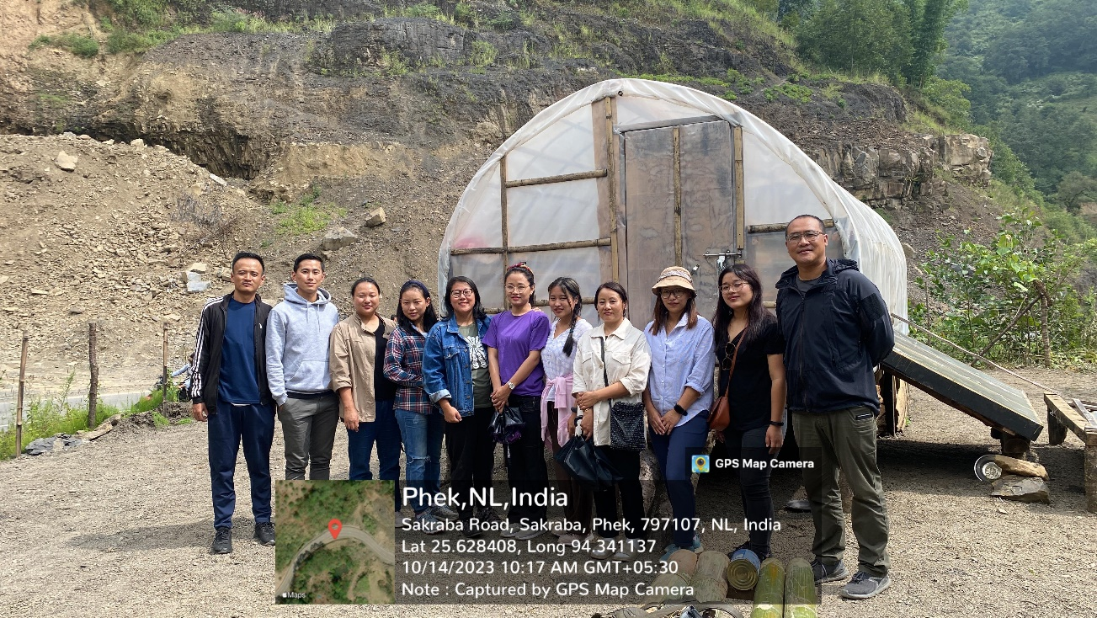

GOVERNMENT OF NAGALAND
OFFICE OF THE PRINCIPAL, PHEK GOVERNMENT COLLEGE
PHEK, NAGALAND
NAAC Accredited B Grade
Attendance Sheet
Date: 14/10/2023
